+ Project Report

|  |  |
| --- | --- |
| Project Title | Design, Develop, Implement, Test & Document Used Car Sales Portal Website |
| Module Name | Application Development & Process |
| Course Name | Applied Degree in Software Engineering |
| Project Start Date | ABC Cars Pte Ltd Portal |
| Project Submission Date | Application Development & Process |

|  |  |  |  |
| --- | --- | --- | --- |
| Student name | | Assessor name | |
| Ajri Muhammad siddik | | Ms.Archana Sakpal | |
| Date issued | Completion date | | Submitted on |
| 04/05/2023 |  | |  |
|  | |  | |
| Project title | Design, Develop, Implement, Test & Document Used Car Sales Portal Website | | |

|  |
| --- |
| Learner declaration |
| I certify that the work submitted for this assignment is my own and research sources are fully acknowledged.  Student signature: Date: 04/05/2023 |

Content

1. Project Background
2. Project Objectives
3. Project Requirement Specifications
4. Task 1
5. Task 2
6. Task 3
7. Task 4
8. Task 5
9. Task 6
10. Task 7
11. Task 8
12. Task 9
13. Task 10
14. Task 11
15. Project Background

ABC Cars Pte Ltd has requested to develop a used car sales portal. Users will be able to register in the portal using the Registration Page. Users of the portal can search for Cars using Make, Model, Registration & Price Range. Users will be able to view the Car information after searching them. The ABC car portal allows users to log in, and post Cars for sale. The scope of this project is to create a testing plan and strategy to appreciate the requirements for implementing RBT as system testing methodology clearly and concisely The scope of this project is to create a testing plan and strategy to appreciate the requirements for implementing RBT as a system testing methodology clearly and concisely.

1. Project Objective

The objectives of this project include performing the following:

* To design, develop a used car sales portal using Spring Boot framework, Spring Security, Spring Data JPA and MySQL server
* To implement the Risk Based Testing (RBT) strategy or spiral SDLC model on the used car sales portal to prepare the testing plan for validation of the client requirements.
* To implement the Risk Based Testing (RBT) strategy or spiral SDLC model on the used car sales portal to prepare the testing plan for validation of the client requirements.
* To identify and analyze the risks associated with the used car sales portal and solving the problems based on the RBT test plan

Tools & platform used

|  |  |
| --- | --- |
| Software | Purpose |
| Spring Tool Suite 3 | Java IDE used to develop java based used car sales website |
| MySQL Workbench | Relational database system which allows information to be stored and retrieve as needed |

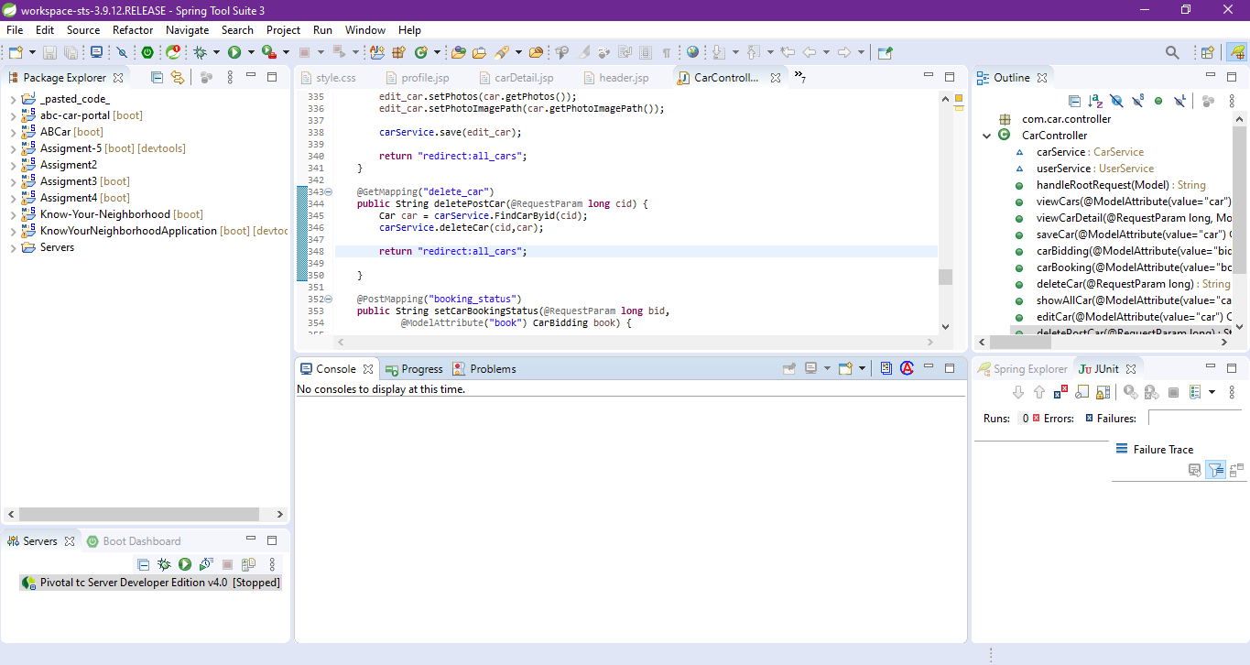Spring Tool Suite 3

Mysql Workbrech

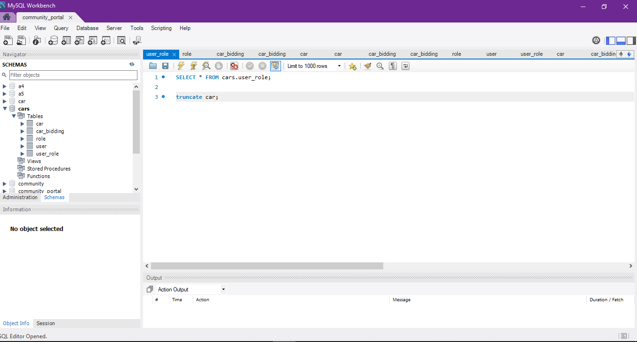

1. Project Requirements Specifications

Project Scope

The used car sales portal is accessible to two types of users: Users and Administrators, both of them has certain functionalities assigned to them, as specified in the following list:

User should be able to perform following functions in the portal

• Register in the Portal

• Login to the Portal

• Post a Car for Sale along with Picture upload

• Deactivate an Existing car sale

• Update their Profile after logging in.

• Book an appointment for test drive

• Post the bidding price

Administrators should be able to perform the following functions in the portal

• Register in the Portal

• Login to the portal

• View List of Registered Users

• Mark a User as Administrator

• Activate / Deactivate a Car post

• Update their profile • Approve or Deny the users appointment based on the

bidding

• Transact the sales if price is right

Both Users & Administrator

• Visit Home Page

• View Car Listing

• Search for a Car by Make, Model, Registration Year & Price Range

• About Us Page

• Contact Us Page

Task 1

Taks Statement :

Create the following items Under “Business Process Section” in Project Presentation

1. Explain the Business Processes the Software is supporting

a. Document 2 Business Process

2. Document 2 Module functionality

a. UI Screenshots

b. Functionality of each of the Screen

Solution :

* 1. Explain the Business Processes the Software is supporting

1. Document 2 Business Process

Scenario 1 - post Car

1. Enter the URL [**http://localhost:8080**](http://localhost:8080) to access the used website ABC cars PTE Ltd (cars sales)
2. Click sign up *“if you do not have account “* and field name, username, Email, password. As new user
3. User will see the register success message with link to login page
4. Enter register username and password in the login page
5. User will then see the home page with the list of sell cars posted by other user
6. Click ‘sell car now’ in home page to post and enter car name, model, Price(RM),Make year, Registration Date and Photo then click on post
7. User will see a post success message with link to the car detail page

* Scenario 2 – Edit Profile

1. Enter the URL [**http://localhost:8080**](http://localhost:8080) to access the used website ABC cars PTE Ltd (cars sales)
2. Click sign up *“if you do not have account “* and field name, username, Email, password. As new user
3. User will see the register success message with link to login page
4. Enter register username and password in the login page
5. User will see the home page and user can click profile in navbar
6. And user can see the profile page. Then user click edit profile to update name, username, Email. And can add mobile and address.
7. And click update and user can see the profile that has been changed
   1. Document 2 Module functionality
8. UI Screenshots
9. Scenario 1 – post Car

|  |
| --- |
| First Click sign up |
| field the registration form |
| and after already field registration. |
| and click sell car now |
| and field the form for sell the car |
| and click the post |
| Click the view |
| and done post car sale already done |

1. Scenario 2.-edit profile

|  |
| --- |
| login account |
| Click the profile |
| click the edit profile |
| Field the form |
| And done   |  |  | | --- | --- | | This before | This after | |

1. Functionality of each of the screen

|  |  |
| --- | --- |
| Pages | Functionallity |
| Registeration | To registration a new user to the Car PT LTD website by obtaining a username, email and password |
| Login | To validate user registered credentials, username and password before user can access the website car sales home page |
| Home | Page seen by user after successful login containing the list of all car posted and post a car sale form |
| Car Detail | Users are able to view comprehensive information about a car either by posting it for sale or by clicking on the "View Car Detail" button from a filtered list of cars available on the homepage or search results. |
| Search Result | The page that appears to the user after performing a search for a particular make, model, registration or price using the search bar located in the header displays a list of cars that match the search keywords. |
| Update Profile | Users are permitted to change their profile details, like their mobile number and address. Additionally, they have the option to monitor the status of their car sale postings and bookings or delete |
| User management | To allow the administrator to view a list of registered users, mark a user as  administrator or update their profile or delete the user |
| Car Management | To allow the administrator to view a list of cars posted, dele car posts, update  status for user booking based on bidding or updating status for car sale |
| About us | The page viewed by the user contains a description of the car seles website |
| Contact us | The page viewed by the user contains his feedback and can see the location of the store |

**Task 2**

The page viewed by the user contains his feedback and can see the location of the store

Task Statement:

Create the following items in “Project Plan in Project Presentation

1. Detail the Software Development Methodology to be used for developing system

2. List the various tasks to be done during various phases

3. Create the Project Plan detailing the various steps to be carried out along with dates

and Timelines

Solution:

**2.1** Detail the Software Development Methodology to be used for developing system

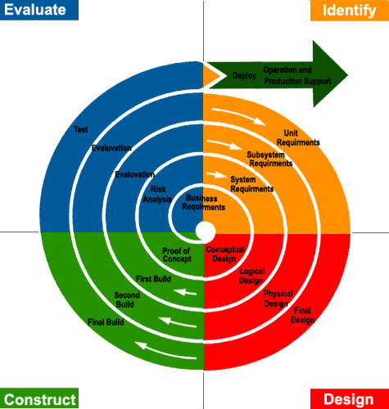 2.1.1 Spiral model

The diagram depicts the spiral model, which is an iterative development model and also shares similarities with the waterfall model, in that each phase must be completed before moving on to the next, and there is no overlapping of phases. However, this model allows for changes to be made at each iteration. This makes it an excellent choice as it incorporates a risk analysis phase, which is helpful for risk management. The development of the used car sales portal is expected to be faster using this model due to the systematic addition of features such as registration, login, and search. This is because changes can be implemented quickly; for example, if a customer is dissatisfied with the registration function during the evaluation phase, changes can be made by returning to the development and testing phase until customer satisfaction is achieved.

Other advantages of the spiral model include ease of cost estimation, as the prototype is developed in small components. During the development phase, individual functions, such as registration, need to be completed first, and after successful evaluation, other functions, such as login or posting, can be added. As a result, less cost is estimated for each cycle of development.

2.2 List the various tasks to be done during various phases

1. Planning & Requirements Gathering:
2. Arrange a meeting with the client to discuss and acquire the essential information about the website's business requirements.
3. Project must clearly define the objectives of the project.
4. To design, develop a used car sales portal using Spring Boot framework, Spring Security, Spring Data JPA and MySQL server.
5. To develop the testing plan for validation of the customer requirements, implement the Risk Based Testing (RBT) strategy or spiral SDLC model on the used vehicle sales platform.
6. To document the used car sales portal website based on spiral model and execute and recording necessary testing under RBT.
7. Identifying and analyzing the risks associated with the used car sales portal, as well as resolving issues based on the RBT test plan
8. Identify the functional and non-functional requirements of software. This includes obtaining information from stakeholders, determining user demands, and establishing the project's scope.
9. Functional requirement
10. User will be able to registered and login in the portal
11. User able to post, Bid, and book for a car
12. Non Function requirement
13. Implement Security
14. Test the performance
15. Identify the project constraints, such as financial, time, and resource constraints.
16. Determine the needs, which include what is? What is it not? incorporated into the application
17. Create a project plan outlining the project timetable, resource allocation, and risk management techniques.
18. Risk Planning / Analysis :

I. Determine what potential risks to the project may exist. Risk identification can be accomplished through brainstorming sessions, stakeholder interviews, and a review of historical data.

II. Assess the likelihood and potential impact of each risk.

III. rank the risks in terms of their probable impact on the project.

IV. Create and implement risk-mitigation measures.

V. Reassess the risk management plan to ensure that it remains effective and relevant.

1. Design,development and testing :
2. Technical Minimum Specification
   1. Hardware

* Processor : Intel i5 gen 8Th vga MX230
* Installed RAM : 12gb
* System type: Windows 64-bit
  1. Software
* Web Server : Apache server
* Web Browser : Goggle Chrome
* Development environment: JDK 1.8.0
* Framework: Spring 3.9.10
  1. Database
* Database server : MySQL
* Database scripting: SQL Script
* Database client: MySQL Workbench

1. User Interface (UI/UX)
2. Wireframes
3. Process Flow
4. Storyboard
5. Prepare integration document
6. Define the business rules
7. Only user can post a car for sale
8. Define the data exchange method from database to user interface
9. Prepare a software development
10. Database Design
11. Entity-Relationship Diagram
12. Logical Diagram
13. Front-End implementation
14. Develop all JSP pages, CSS, Javascript
15. Back-End implementation
16. Develop the entity
17. Create a repository
18. connect the business process
19. Prepare test case document
20. Define the test case for unit testing
21. Validate registration function
22. Conduct Unit Testing
23. Review the test case
24. Run the test cases
25. Record the result
26. Compare expected to actual result
27. Record the result status either success or fail
28. Check the accuracy and debug
29. Make relevant changes to the front end web pages
30. Conduct user acceptance testing (UAT)
31. Define the UAT test case
32. Run the UAT test case
33. Record the result
34. Evaluation :

I. Create a website demo for the client.

II. Collect consumer feedback and satisfaction

III. Modify the website in response to client feedback by returning to the development and testing phases if customer approval has not yet been obtained.

IV. Continue to the following phase until the consumer approves and the website is entirely constructed.

V. A confirmation webpage has been created, as well as an SRS document.

VI. Obtains customer approval to implement the program. This includes showing the customer the program and getting their approval on the deployment plan.

VII. Product is ready for use

Upload the created used car portal website to the web server

* 1. Create the Project Plan detailing the various steps to be carried out along with dates and Timelines <less than a month> 28-5

|  |  |  |  |
| --- | --- | --- | --- |
| Phases | Activity | Start Date | End Date |
| Planning | Arrange a meeting with the client to  gather the business requirement for  the website | 28/04/2023 | 28/04/2023 |
|  | Prepare the Statement of Work  (SOW) – Project scope | 29/04/2023 | 29/04/2023 |
|  | Define Project Objective | 29/04/2023 | 29/04/2023 |
|  | Identify the functional and non functional requirement | 29/04/2023 | 29/04/2023 |
|  | Identify the constraint (Budget, Time, etc) | 29/04/2023 | 29/04/2023 |
|  | Resource planning | 29/04/2023 | 29/04/2023 |
|  | Identify the needs | 30/04/2023 | 30/04/2023 |
|  | Develop a plan | 30/04/2023 | 30/04/2023 |
| Risk Analysis | Arrange a meeting and Identify what could be the risk that will impact the project. | 30/04/2023 | 30/04/2023 |
|  | Prepare risk strategy & assessment – Qualitative risk analysis chart | 30/04/2023 | 30/04/2023 |
|  | Mitigate the risk | 01/04/2023 | 01/04/2023 |
| Development & Testing | Define Technical specifications | 01/04/2023 | 01/04/2023 |
|  | Prepare user interface | 01/04/2023 | 01/04/2023 |
|  | Prepare database design | 02/04/2023 | 02/04/2023 |
|  | Front-end implementation | 02/04/2023 | 02/04/2023 |
|  | Database implementation | 02/04/2023 | 02/04/2023 |
|  | Business logic implementation | 03/04/2023 | 03/04/2023 |
|  | Prepare test cases for testing | 03/04/2023 | 03/04/2023 |
|  | Conduct UAT | 03/04/2023 | 03/04/2023 |
|  | Record testing result | 03/04/2023 | 03/04/2023 |
|  | Check accuracy and debug | 03/04/2023 | 03/04/2023 |
|  | Make relevant changes to front-end | 03/04/2023 | 03/04/2023 |
| Evaluation | Prepare website demo for customer | 04/04/2023 | 04/04/2023 |
|  | Retrieve feedback from customer | 04/04/2023 | 04/04/2023 |
|  | Project sign off betweeen client and project manager | 04/04/2023 | 04/04/2023 |
|  | Used car sales portal ready for deployment | 05/05/2023 | 05/05/2023 |

**Task 3**

Explain risk-based testing concepts and requirements with the following details

Solution:

3.1.1 What is the risk?

Risk is the possibility that something unpleasant will occur as a result of a decision or action you take. The higher the risk, the greater the possibility of anything bad happening and the worse the repercussions.

3.1.2 RBT stages

Risk-Based Testing (RBT) is a testing approach that involves applying risk management principles to guide the testing process.

* + - 1. **Risk identification**

**Various ways to identify risks in sofware development:**

1. Brainstorming

2. Requirement analysis

3. Historical data analysis

4. Interviewing etc.

The risk can also be categorized into 3 categories of:

* + - 1. Known risks: These are known hazards that may be identified and assessed based on previous experiences, historical data, or project expertise.
      2. Unknown risks: These are risks that develop during the project's testing phase but were not foreseen beforehand (e.g., unexpected software behavior, testing delays brought on by a rapid emergence of a fault).
      3. Unknowable risks: dangers that cannot be foreseen but could have a significant effect on the project (e.g., system down for more than a day, natural disasters).

Risk management in software development is mostly dependent on the identification of risks and their documentation in a spreadsheet or risk register.

* + - 1. Risk Strategy & Assesment

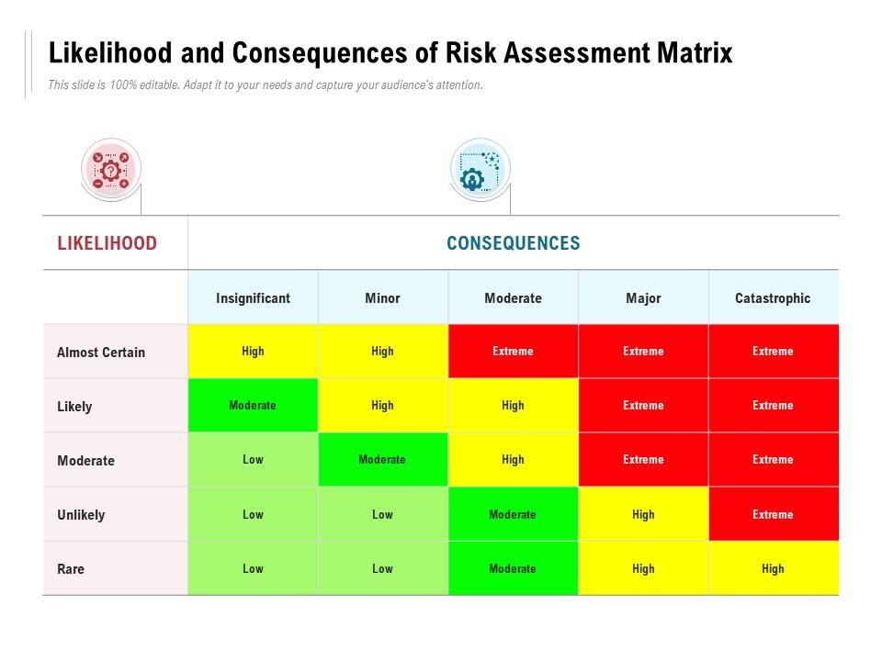The risk matrix is a tool to help project managers in comprehending the likelihood of a risk occurring and the impact it would have on the project. Project managers can prioritize which hazards deserve the most attention by putting a value on them according to a scale. It serves as a means of ensuring that hazards are recognized and dealt with in a methodical and efficient manner.

* + - 1. Risk Mitigation

Developing a response strategy to manage risks comes next once risks have been identified and evaluated. The response plan can comprise either getting rid of the danger or lessening its effects to a manageable level. This is known as risk minimization, and it is an important aspect of risk management in software development.

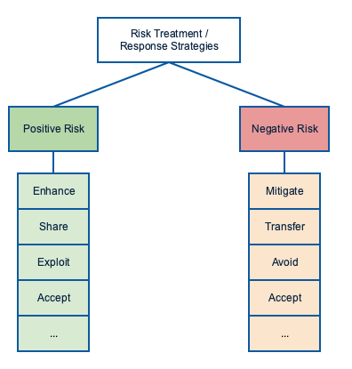

* + - 1. Risk Monitoring and Control

Risk monitoring and control entails checking for any residual hazards and detecting new ones that may occur over the course of the project on a regular basis. The team can utilize approaches such as reassessing risks, conducting audits, analyzing trends, and updating project status in meetings to monitor and control risk.

* + 1. **Eight characteristics of Software Product Quality**

The used car sales portal is to be developed into a product which satisfies the ISO/IEC 25010:2011 software product quality. Therefore, the website is to be tested based on its functional suitability, performance efficiency, compatibility, usability, reliability, security, maintainability and portability

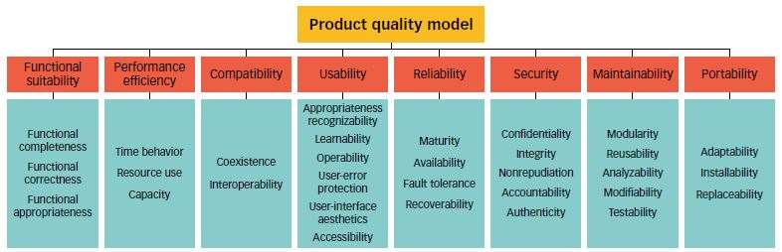

* + - 1. **Functional suitability**

Functional suitability is meant by how well can the used car portal able to provide functions completely with no lacking requirements, producing the correct outcome expected when a user complete a specified task and objectives

* + - 1. **Performance efficiency**

Processing speed or time play a big role for the user when utilizing the portal feature and therefore should not show any lagging. The portal should also have the capacity in accommodating many users with ease.

* + - 1. **Compatibility**

Compatibility refers to how well can the used car portal function efficiently in different environment or browsers.

* + - 1. **Usability**

Usability refers to the capability of the portal in allowing the user to easily learn to use the website features, protecting the user from making errors and a pleasant user interface.

* + - 1. **Reliability**

Reliability refers to how well the portal can perform under specified conditions in case of any faulty software/hardware or recoverable in the event of interruption/ failure

* + - 1. **Security**

Security refers to the portal capability in protecting data from security vulnerabilities. At the same time, the portal must ensure the confidentiality of user data from unauthorized access.

* + - 1. **Maintainability**

The portal should be maintainable by allowing any modifications to be made with minimal impact on other feature. Also, can be tested easily to determine whether defined test criteria has been met.

* + - 1. **Portability**

Portability refers to how well the portal can adapt in different hardware or any usage environment such as laptop, iPad/tablet or phone. The portal should also have the capability to replace another comparable product.

**3.2Types of Risk**

|  |  |  |  |
| --- | --- | --- | --- |
| *Type of risk* | *Risk identification* | *Risk description* | *Impact* |
| *Functional Risk* | Login Risk | User cannot login | If the user is unable to log in, they will not be able to use all the features provided on the website. |
|  | Searching Risk | User cannot search for a car | User cannot easily find a specific car in the portal and may need to search manually |
|  | Posting a Car Risk | User cannot post their car for sale | User cannot post their car to sell it on the portal. |
|  | Viewing Car Detail Risk | User cannot view selected car details | User cannot bid, book, or see details for a particular car. |
| Non-Functional Risk | Performance Risk | Home page does not load within the expected time | The user may lose interest or patience and choose another website. |
|  | Compatibility Risk | Home page has different look and feel in different browsers | User may lose interest due to differences in user interface. |
|  | Maintainability Risk | Used car portal cannot be modified or changed | Users may judge the portal as not up to date. |
|  | Usability Risk | Portal is difficult to navigate or lacks clear labels or instructions | Users may find it difficult to learn and use the software, leading to frustration and potential abandonment of the product. |
| Technical Risk | Security Risk | User is not authenticated correctly after logging in | User will not be able to log in to the portal and reach the home page. |
|  |  | Navigation is not properly authorized based on the user's login role assigned | The user may have unauthorized access to sensitive information or functionality. |
|  |  | SQL injection | It can lead to data breaches, loss of sensitive information, and compromise of system integrity. |
|  | Portability Risk | Used car sale portal look and feel is different in phone/mobile devices | Users who are familiar with using a specific device may lose interest in using the website. |

Task 4

Task Statement

Create the following items under “Test Planning” in Project Report

1. Establish the test phases of security testing with its prioritization
2. Develop the detailed test plan with test cases based on quantitative risk analysis
3. Create a test risk matrix with the evaluation of the impact

Solution

4.1 Establish the test phases of security testing with its prioritization.

(a) RBT Test Strategy in car portal project

1. What is security testing ?

Security testing is a type of software testing that is focused on identifying vulnerabilities and weaknesses in an application or system's security measures. The objective of security testing is to ensure that the system or application is secure from potential threats such as hacking, unauthorized access, data breaches, and other cyber-attacks.

2. Types of Security Testing

|  |
| --- |
| What is Security Testing? Example |

* Vulneralibility scanning : identify known vulnerabilities in the system or network.
* Security scanning : This can be done either manually or using automated tools to identify weaknesses in the system and network, with the aim of reducing the risk.
* Penetration testing : An external attack simulation is carried out to identify potential vulnerabilities in the system or network.
* Risk assesment : This involves analyzing security risks and classifying them as low, medium, or high, and identifying measures to reduce them.
* Security auditing : This involves inspecting the code line by line to identify security flaws.
* Posture assessment : Ethical hackers are employed to identify security flaws in the system.
* Ethical hacking : This involves combining security scanning, ethical hacking, and risk assessment to determine the overall security posture of an organization

**(b) Among test strategies, how to carry security testing.**

The ABC Cars Project’s Security Testing Process

The process of discovering, assessing, and analyzing potential risks that might have an impact on an organization's operations, assets, or goals is known as risk assessment. Determine the possibility and impact of these risks by identifying potential threats and vulnerabilities that could have an impact on the organization. The procedure includes the following steps:

1. Risk identification: In this step, prospective threats to the organization are identified, such as cyberattacks, natural catastrophes, or other security occurrences.

2. Risk Analysis: In this step, each identified risk's likelihood and impact are evaluated. The impact is established by taking into account the likelihood that the risk will materialize, whereas the likelihood is determined by taking into account the possibility that the risk will occur.

3. Reducing the risk: During this phase, methods are developed to control and reduce the risks that have been identified.

**(c) Test phases in security testing**

Security testing is a crucial component in every phase of a software development life cycle (SDLC) to ensure that the final product is secure.

1. During the requirement phase, perform a security analysis to look for any possible misuse scenarios that could be dangerous to security.

2. Design: Identify potential security concerns and develop a strategy for resolving them.

3. Testing that involves coding and unit testing should be done by testers who are familiar with the internal workings of the website's code.

4. Integration testing: test the website's functionality without taking the internal system architecture into account.

5. System testing: To find any potential vulnerabilities in the entire website, testing and vulnerability scanning should be done.

6. Implementation: In addition to vulnerability screening, penetration testing should be carried out to mimic an attack by a malicious hacker.

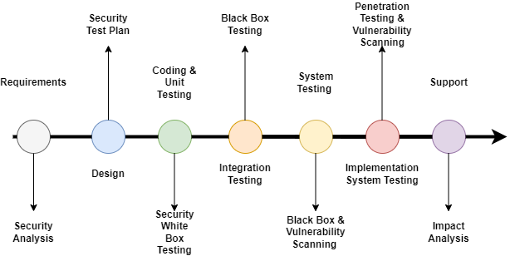7. Support: To fix any vulnerabilities found during testing, patches and software updates should be applied.

* 1. Develop The Detailed test plan with test cases based on quantitative risk
     1. The testing plan for the used car portal includes the following testing

1. Functional Testing - UAT test cases - 5 atleast
2. Compatibility - Cross-browser testing / responsiveness
3. Performance Efficiency - Load Testing/ Stress testing
4. Usability testing - Prototyping
5. Security - Security testing (IU 5) / Spring Security (Priority Testing)
6. SQL injection
7. Logging
8. Authentication and Authorization
9. Portability - Multi platforms (different platforms, different devices)
10. Reliability – same with usability testing
11. Maintainability – Using Spring (Dependency Injection), Junit Testing

4.2.2. Test Plan Table

The test plan includes the following:

1. Test Scenario
2. Test Cases (Under one scenario, there may be more than one test cases)
3. Test Objectives
4. Expected Outcome
5. Risk
6. Techniques (Types of testing)

|  |  |  |  |  |  |  |  |
| --- | --- | --- | --- | --- | --- | --- | --- |
| Risk Id | Test Scenario ID | Test Scenario | Test Objective | Test Priority | Risk | Technique | Expected Results |
| 1 | UA001 | Ensure user can register in the portal | To allow user to register with their credentials (name, username, email, password) successfully | High | User is not able to register with their credentials | UAT Testing | After registering user will see the succes message and their credentials saved in the database |
| 2 | UA002 | Ensure user can login in the portal | To allow user to login with registered credentials | High | User is not able to log in with registered credentials | UAT Testing | After login, user will reach to the home page |
| 3 | UA003 | Ensure user car post a car in the portal | To allow user to post a car in the portal | High | User is not able to post a car in the portal | UAT Testing | Users can post their car in the portal |
| 4 | UA004 | Ensure user can search and view car detail | To allow user to search a particular car in the portal | High | User is not able to find the expected car | UAT Testing | After giving the keyword user will see matched search result |
| 5 | UA005 | Ensure user can update his profile | To allow user to update their profile | High | Users is not able to update their profile | UAT Testing | Users can see updated details in their profile |
| 6 | TS001 | Validating registration functionality | To check registed data stored successfully | High | User is not able to register in the portal | Unit Testing | After checking, junit should return a passing result as user data can be save |
| 7 | TS002 | Validating login functionality | To check credentials are existing in the system | High | User is not able to log in to the portal | Unit Testing | After checking, junit should return a passing result as user data exist/presen t in the system |
| 8 | TS003 | Ensure car can be added/ saved | To test posting a car | High | User not able to post a car | Unit Testing | After checking, junit should return a passing result as car data can be saved |
| 9 | TS004 | Checking search functionality | To test searching functionality | High | User not able to find a car | Unit Testing | After checking, junit should return a passing result as any car can be search with matching requirement s |
| 10 | TS005 | Ensure the functionality of bidding price for a selected car | To test adding a bid worked properly | High | User not able to bid for a car | Unit Testing | After checking, junit should return a passing result as Project Report NICF Capstone Project using Java Page | 28 bidding data can be save |
| 11 | PM001 | Testing the performance of registration page | To utilize the page’s loading speed of the registration page using Chrome DevTools | Extreme | User will lose interest and does not want to use the application | Performance Testing | After testing, The loading time speed should be above 80 – 90% or less than 1s. |
| 12 | CB001 | Ensure register page maintain a consistent look and feel in different browser (Chrome, Edge, Firefox) | To check a consistent look and feel of the register page across different browser | High | User may feel irritated with the different look and feel in the register page and lose credibility on the portal | Compatibility Testing | After testing, register page maintain a consistent look and feel across different browser |
| 13 | CB002 | Ensure login page maintain a consistent look and feel in different browser (Chrome, Edge, Firefox) | To see a consistent look and feel of the login page across different browser | High | User may feel confused with the different look and feel in the login page and lose credibility on the portal | Compatibility Testing | After testing, Register page should have consistent look and feel across different browser |
| 14 | CB003 | Ensure home page maintain a consistent look and feel in different browser (Chrome, Edge, Firefox) | To see a consistent look and feel of the home page across different browser | High | User may feel confused with the different look and feel in the home page and lose credibility on the portal | Compatibility Testing | After testing, home page should have consistent look and feel across different browser |
| 15 | CB004 | Ensure car detail page maintain a consistent look and feel in different browser (Chrome, Edge, Firefox) | To see a consistent look and feel of the car detail page across different browser | High | User may feel confused with the different look and feel in the car detail page and lose credibility on the porta | Compatibility Testing | After testing, car detail page should have consistent look and feel across different browser |
| 16 | CB005 | Ensure profile page maintain a consistent look and feel in different browser (Chrome, Edge, Firefox) | To see a consistent look and feel of the profile page across different browser | High | User may feel confused with the different look and feel in the profile page and lose credibility on the porta | Compatibility Testing | After testing, profile page should have consistent look and feel across different browser |
| 17 | PB001 | Ensure register page maintain a consistent look and feel in different devices (laptop, iPad, phone) | To ensure all feature in the register page is visible to the user in different devices | High | User may lose interest and chose a different option as the website are not able to adapt to their device of choice | Portability Testing | After testing, all register page is visible to the user in different devices (laptop, iPad and phones) |
| 18 | UB001 | Test whether the register page is userfriendly in design | To ensure all navigation in header and footer works properly and the content is visible | High | User will be unable to fully utilize the function in the register page | Usability Testing | User will be able to use all navigation links in the register page properly and understand the flow of features available |
| 19 | UB002 | Test whether the login page is userfriendly in design | To ensure all navigation in header and footer works properly and the content is visible | High | User will be unable to fully utilize the function in the login page | Usability Testing | User will be able to use all navigation links in the login page properly and understand the flow of features available |
| 20 | UB003 | Test whether the home page is userfriendly in design | To ensure all navigation in header and footer works properly and the content is visible | High | User will be unable to fully utilize the function in the home page | Usability Testing | User will be able to use all navigation links in the home page properly and understand the flow of features available |
| 21 | UB004 | Test whether the car detail page is userfriendly in design | To ensure all navigation in header and footer works properly and the content is visible | High | User will be unable to fully utilize the function in the car detail page | Usability Testing | User will be able to use all navigation links in the car detail page properly and understand the flow of features available |
| 22 | UB005 | Test whether the profile page is userfriendly in design | To ensure all navigation in header and footer works properly and the content is visible | High | User will be unable to fully utilize the function in the profile page | Usability Testing | User will be able to use all navigation links in the profil page properly and understand the flow of features available |
| 23 | SE001 | Ensure user is authentica ted correctly after logging in | To ensure Spring Security login feature is authenticated correctly | High | User will not be able to log in to the portal and reach the home page | Security testing | User will be able to reach respective home page based on role assigned |
| 24 | SE002 | Ensure after logging in, user home page navigation is authorized correctly based on role assigned | To ensure Spring security authorization is working correctly on the navigation bar | Extreme | User with role assigned could not fully utilize feature based on assigned role and expose all user’s data to unauthorize d access compromisi ng user confidentiali ty | Security testing | User with user role can post car and buy car while user with administrato r role can manage user and car data |
| 25 | SE003 | Checking for SQL injection | To ensure search input data is not vulnerable to an SQL injection | Extreme | User with ill intent will be able to access database data and retrieve sensitive information | Security testing | No return is given as a result from the injected SQL Query |

* 1. Create a test risk matrix with the evaluation of the impact
     1. How Risk Evaluation is conducted.

Quantitative Risk Analysis

1. Identify risk related to ABC used car portal
2. Calculate the risk by multiplying the likelihood by the consequences

*Risk = Likelihood x Consequence*

*Risk = 2 x 4 = 8*

1. The result of the risk value (8), based on the Risk Matrix diagram below will be in the scale of High.



Test Risk Matriks

Test Risk Matriks

|  |  |  |  |  |  |  |
| --- | --- | --- | --- | --- | --- | --- |
| Risk ID | Risk | Likelihood  (1-5) | Impact  (1 – 5) | Type of  Testing | Risk  Rating | Risk Level |
| 1 | User is not be able register in the system | 3 | 4 | UAT Testing | 12 | High |
| 2 | User will not be able to reach the portal home page to post or view cars | 3 | 4 | UAT Testing | 12 | High |
| 3 | User will not be able to sell their car | 3 | 4 | UAT Testing | 12 | High |
| 4 | User will not be able to find the car expected | 3 | 3 | UAT Testing | 9 | High |
| 5 | User will not be able to complete their profile information | 3 | 3 | UAT Testing | 9 | High |
| 6 | User will not be able to login to the portal | 3 | 4 | Unit Testing | 12 | High |
| 7 | User will not be able to register in the portal | 3 | 4 | Unit Testing | 12 | High |
| 8 | User will not be able to post a car in the portal | 3 | 4 | Unit Testing | 12 | High |
| 9 | User will not be able to search for any car | 3 | 3 | Unit Testing | 9 | High |
| 10 | User will not be able to bid for any car | 3 | 4 | Unit Testing | 12 | High |
| 11 | User will lose interest and will not register to login and access the home page to buy or sell car | 4 | 4 | Performance Testing | 16 | Extreme |
| 12 | User may feel irritated with the different look and feel in the register page and lose credibility on the portal | 3 | 3 | Compatibility Testing | 9 | High |
| 13 | User may feel irritated with the different look and feel in the login page and lose credibility on the portal | 3 | 3 | Compatibility Testing | 9 | High |
| 14 | User may feel irritated with the different look and feel in the home page and lose credibility on the portal | 3 | 3 | Compatibility Testing | 9 | High |
| 15 | User may feel irritated with the different look and feel in the car detail page and lose credibility on the portal | 3 | 3 | Compatibility Testing | 9 | High |
| 16 | User may feel irritated with the different look and feel in the profile page and lose credibility on the portal | 3 | 2 | Compatibility Testing | 6 | High |
| 17 | User may lose interest and chose a different option as the website are not able to adapt to their device of choice | 3 | 4 | Portability Testing | 12 | High |
| 18 | User will be unable to fully utilize the function in the register page | 3 | 4 | Usability Testing | 12 | High |
| 19 | User will be unable to fully utilize the function in the login page | 3 | 4 | Usability Testing | 12 | High |
| 20 | User will be unable to fully utilize the function in the home page | 3 | 4 | Usability Testing | 12 | High |
| 21 | User will be unable to fully utilize the function in the car detail page | 3 | 4 | Usability Testing | 12 | High |
| 22 | User will be unable to fully utilize the function in the profile page | 3 | 3 | Usability Testing | 9 | High |
| 23 | User will not be able to log in to the portal and reach the home page | 3 | 4 | Security Testing | 12 | High |
| 24 | User with role assigned could not fully utilize feature based on assigned role and expose all user’s data to unauthorized access compromising user confidentiality | 3 | 5 | Security Testing | 15 | Extreme |
| 25 | User with ill intent will be able to access database data and retrieve sensitive information | 3 | 5 | Security Testing | 15 | Extreme |

Task 5

Task Statement

Create the following items under “Testing Strategy” in Project Report

1. Design suitable RBT cycle content and priorities further test cycles
2. Communicate the details of the strategy and test planning to the key stakeholders with proper justifications

Solution

Design suitable RBT cycle content and priorities further test cycles

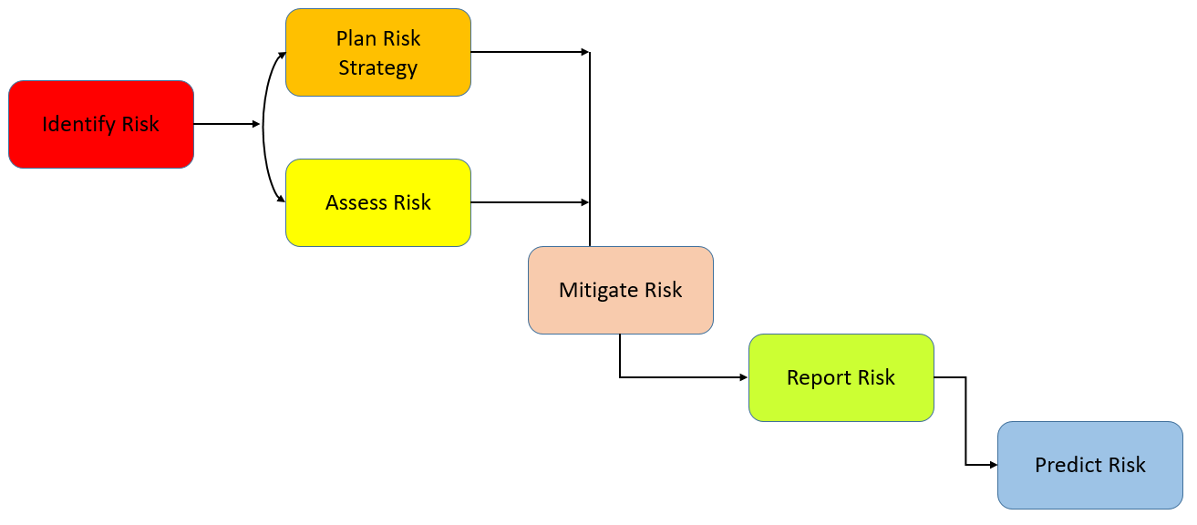

8.1.1 Identify risk

• Check to see that the requirements have been thoroughly examined based on the customer specification for the ABC Car Portal • Begin identifying the risk based on various techniques by conducting an interview to acquire information.

• Engages in brainstorming to identify potential threats to the used vehicle gateway.

List all detected risks so that they can be prioritized depending on threats.

8.1.2 Plan a risk plan.

• Filter the risks that have been identified, taking into account their likelihood and potential effects on the used car portal.

• Use the Risk Matrix to prioritize which hazards to test in the test plan by calculating the overall amount of risk.

* + 1. Mitigate risk
* Contacting each stakeholder and setting up meetings to discuss possible solution to the issue/risk and getting updates on the risk which has been managed previously for the portal (Thomas, 2022)
* Create a centralized system where all risk data are recorded and can become a reference for future management of risk (Hunt, 2019)
* Consulting with risk analyst or an expert in order to eliminate or contain the risk as much as possible.
  + 1. Report risk
* Record the outcome or log of the risk-based testing for the used car portal and forward the report to the development team so that the issue can be fixed for the failed test cases.
  + 1. Predict risk

• Predict the outcome of future risk based on assessed risk and creating a contingency plan as a workaround for any unforeseen events.

* 1. Communicate the details of the strategy and test planning to the key stakeholders with proper justifications

8.2.1 Justify the selection of test methods based on quantified risk to a project.

|  |  |
| --- | --- |
| Type of Testing | Main Purpose |
| Functional Testing | This testing focuses on validating the user and administrator-specific functions listed in the project requirement specification, such as login, registration, seeing automobile details, and posting.  Search for a new automobile by make, model, price, and registration information. |
| Security Testing | This testing identifies weaknesses, risks, and threats to the used vehicle portal against hostile intrusions that could result in the loss of data, money, or the reputation of the portal. The use of malicious SQL statements injected into an input field, such as the search bar, to obtain and update data in the portal database is one method of attack that is possible (WHAT IS SQL INJECTION?, n.d.). The confidentiality of user data will be jeopardized, and the portal will become exposed, exposing the design of the database. In order to properly authenticate or validate the user during the login stage and authorize which links a user can access based on their role, Spring Security is essential. |
| Performance Testing | To ensure a better user experience, this testing focuses on analyzing the speed and responsiveness of the portal web pages, such as the signup page. |
| Compatibility Testing | This testing, also known as cross-browser testing, guarantees that the portal can provide an excellent user experience in any browser of choice and can find any compatibility issues, such as those with Chrome, Edge, or Firefox. |
| Portability Testing | To maintain the portal's endurance and ability to adapt to ongoing change, which necessitates regular updating to save costs, this testing will examine the portal's compatibility with various commercially available devices, such as phones, tablets, and laptops. |
| Usability Testing | The purpose of this testing is to see how simple it is for users to navigate the used vehicle portal and assess how easily users can utilize the features to accomplish tasks like listing a car or searching for a car. |

* What is stakeholder?

Stakeholders can be an individual, groups or organizations that have an influence in a software project or they may be actively involved or having an interest which may affect the success or failure of the project. They have the authority throughout the project lifecycle and different degrees of responsibilities. (Paspelava, 2021)

* Why is it important to communicate risk to key stakeholders? (Jarrad, 2019)
* Promote Accountability

By communicating potential risk to teams and stakeholders, there will be better understanding in allocating roles and responsibilities to the right people. As a Project manager for a used car portal, it is important to make the right call on individual who can deal with an issue to ensure the project stays on track.

* Provide realistic expectations

A transparency in communicating with stakeholders regarding a potential risk will allow them to have an awareness or realistic view on how the risk may affect the project especially the timeline. Since a significant number of finances have been invested by the stakeholders, the right gesture is to be transparent on the current situation and the stakeholders will likely have more confidence and trust on the project.

* Unify the team

Proper communication enables a team to respond to risk instantly as there are less confusion and have better understanding on the potential risk. In this way, there is no need for an informant as the information is shared and the issue can be tackled easily

• How to communicate risk to stakeholders?

* Involving the team

The entire project team is involved in risk management, especially specialists who are knowledgeable in certain risk areas or aspects of the project.

Instead of relying solely on the project manager as their only point of contact, stakeholders can get more relevant information and develop realistic expectations by speaking with experts.

* Consider stakeholder location

Due to better participation and the fact that project team members are ideally situated inside the stakeholder's region, country, or time zone, face-to-face communication helps strengthen working relationships. If there are remote team members, they can use a central hub to quickly connect with stakeholders and provide them more foresight. Team members will be able to answer to stakeholder questions and concerns with ease.

* Utilize technology

There are various risks analysis technology available to be use by team members to ensure an accurate assessment of risk like the cost risk tool which can perform risk analysis and meeting the financial expectations. Other tools like the schedule risk tool ensures the stakeholder end date are met through prioritized risk analysis preventing any delay to the schedule. Exploring and utilizing tools available will ensure a continuous support from stakeholder and can provide the right data to stakeholder.

* Use reporting and alerts

Alerts can be set up to make sure that all parties are routinely informed and aware of any potential risks. By doing this systematically, it is possible to analyze frequent problems and inform stakeholders about prospective problems that can arise.

Task 6

Create the following items under “Testing Results” in Project Report

1. Execute the risk-based test pan and log the test results

2. Modify the risk-based test procedure with the reasons

1 Execute the risk-based test pan and log the test results

I. Functional Testing(Unit Testing)

|  |  |  |  |
| --- | --- | --- | --- |
| Requirement | Test Scenario ID | Test Scenario | Number of Test Cases |
| Functional Testing | TS001 – Unit Testing | Validating registration functionalit | 1 |
| TS002 – Unit Testing | Validating Login functionality | 1 |
| TS003 – Unit Testing | Check if car data can be added/save | 1 |
| TS004 – Unit Testing | Check if car can be search | 1 |
| TS005 – Unit Testing | Check if bidding price can be saved | 1 |

|  |  |  |  |  |  |  |  |  |
| --- | --- | --- | --- | --- | --- | --- | --- | --- |
| Scenario ID | Test CaseID | Test Case | Preconditions | Steps | Test Data | Expected Results | Actual Results | Pass/Fail |
| TS001 | TC001 | Check if registered data can be saved | Implementation of ABC Car Portal is complete with all webpages and navigation links and uploaded on localhost server | 1.Run Test script shown in screenshot below | Name= muhammad  Username= ajri  Email= [amelia@gmail.com](mailto:amelia@gmail.com)  Password= watson123 | After checking, junit should return a passing result as user data can be save | Not as expected, | Fail |

|  |  |
| --- | --- |
| Evidence |  |

|  |  |  |  |  |  |  |  |  |
| --- | --- | --- | --- | --- | --- | --- | --- | --- |
| Scenario ID | Test CaseID | Test Case | Preconditions | Steps | Test Data | Expected Results | Actual Results | Pass/Fail |
| TS002 | TC002 | Check if user credential is existing in the system | Implementation of ABC Car Portal is complete with all webpages and navigation links and uploaded on localhost server | 1. Run Test script shown in screenshot below | Username= Ajri | After checking, junit should return a passing result as user data exist/present in the system | As expected, | pass |

|  |  |
| --- | --- |
| Evidence |  |

|  |  |  |  |  |  |  |  |  |
| --- | --- | --- | --- | --- | --- | --- | --- | --- |
| Scenario ID | Test CaseID | Test Case | Preconditions | Steps | Test Data | Expected Results | Actual Results | Pass/Fail |
| TS003 | TC001 | Validate if car information can be added successfully | Implementation of ABC Car Portal is complete with all webpages and navigation links and uploaded on localhost server | 1. Run Test script shown in screenshot below | name = Toyota MX300  model= Toyota Price = 200000 Make Year = 2020  Registration Date = Jan 2023 | After checking,junit should return a passing result as car data can be saved | As expected, | Pass |

|  |  |
| --- | --- |
| Evidence |  |

|  |  |  |  |  |  |  |  |  |
| --- | --- | --- | --- | --- | --- | --- | --- | --- |
| Scenario ID | Test CaseID | Test Case | Preconditions | Steps | Test Data | Expected Results | Actual Results | Pass/Fail |
| TS004 | TC001 | To test searching for a car | Implementation of ABC Car Portal is complete with all webpages and navigation links and uploaded on localhost server | 11. Run Test script shown in screenshot below | Search input = Toyota | After checking, junit should return a passing result as any car can be search with matching requirements | As expected, | Pass |

|  |  |
| --- | --- |
| Evidence |  |

|  |  |  |  |  |  |  |  |  |
| --- | --- | --- | --- | --- | --- | --- | --- | --- |
| Scenario ID | Test CaseID | Test Case | Preconditions | Steps | Test Data | Expected Results | Actual Results | Pass/Fail |
| TS005 | TC001 | To test saving bidding information | Implementation of ABC Car Portal is complete with all webpages and navigation links and uploaded on localhost serve | 1. Run Test script shown in screenshot below | Bidding price = 10000 Car Name = Toyota MX3000User name = ajri | After checking, junit should return a passing result bidding information is saved | As expected, | Pass |

|  |  |
| --- | --- |
| Evidece |  |

II. Functional Testing (UAT Testing)

|  |  |  |  |
| --- | --- | --- | --- |
| Requirement | Test Scenario ID | Test Scenario | Number of Test Cases |
| Functional Testing | UA001 – UAT Testing | Ensure user can register in the portal | 2 |
| UA002 – UAT Testing | Ensure user can login in the portal | 2 |
| UA003 – UAT Testing | Ensure user can post a car in the portal | 2 |
| UA004 – UAT Testing | Ensure user can search a car | 2 |
| UA005 – UAT Testing | Ensure user can update profile | 2 |

|  |  |  |  |  |  |  |  |  |
| --- | --- | --- | --- | --- | --- | --- | --- | --- |
| Scenario ID | Test CaseID | Test Case | Preconditions | Steps | Test Data | Expected Results | Actual Results | Pass/Fail |
| UA001 – UAT Testing | UATC001 | Check all the mandatory fields are entered | The ABC Car Portal has been fully implemented with all of its webpages and links to other websites, as well as localhost server uploads | 1. Enter URL localhost:8080  2.Click “Register” on website navigation bar  3. Enter all the fields.  4. Click Register. | Name= Ajri muhammad siddik Username = ajri Email= ajri@gmail.com Password= ajei123 | After registering, user will see a successful registration message and a login link. | As expected, P | Pass |

|  |  |
| --- | --- |
| Evidence |  |
|  |
|  |
|  |  |

|  |  |  |  |  |  |  |  |  |
| --- | --- | --- | --- | --- | --- | --- | --- | --- |
| Scenario ID | Test CaseID | Test Case | Preconditions | Steps | Test Data | Expected Results | Actual Results | Pass/Fail |
| UA001 UAT | UATC002 | Check registration not blank validation working correctly | Implementation of ABC Car Portal is complete with all webpages and navigation links and uploaded on localhost server | 1. Enter URL localhost:8080 2. Click “Sign up” on website 4. And will to direction in registeration page | Name= Username = Email= Password= | After submitting the register data, user will see the browser default validation message ‘Please fill out this field’ | As expected, P | fail |

|  |  |
| --- | --- |
| Evidence |  |

|  |  |  |  |  |  |  |  |  |
| --- | --- | --- | --- | --- | --- | --- | --- | --- |
| Scenario ID | Test CaseID | Test Case | Preconditions | Steps | Test Data | Expected Results | Actual Results | Pass/Fail |
| UA002 UAT | UATC001 | Check all the mandatory fields are entered | Implementation of ABC Car Portal is complete with all webpages and navigation links and uploaded on localhost server | 1. Enter URL localhost:8080  2. Enter all the fields.  3. Click Sign in | Name= Username = Email= Password= | Username = ajri Password= ajri123 | As expected, P | Pass |

|  |  |
| --- | --- |
| Evidance |  |

|  |  |  |  |  |  |  |  |  |
| --- | --- | --- | --- | --- | --- | --- | --- | --- |
| Scenario ID | Test CaseID | Test Case | Preconditions | Steps | Test Data | Expected Results | Actual Results | Pass/Fail |
| UA002 UAT | UATC002 | Check login validation working correctly | Implementation of ABC Car Portal is complete with all webpages and navigation links and uploaded on localhost server | 1. Enter URL localhost:8080 2. Enter password incorrectly 3. Click Log In without entering any information. | Username = ajriPassword= ajri12345 | After login, user will see an error message to try again or register back | As expected, | faill |

|  |  |
| --- | --- |
| Evidence |  |
|  |  |

|  |  |  |  |  |  |  |  |  |
| --- | --- | --- | --- | --- | --- | --- | --- | --- |
| Scenario ID | Test CaseID | Test Case | Preconditions | Steps | Test Data | Expected Results | Actual Results | Pass/Fail |
| UA003 UAT | UATC001 | Check if user can successfully post a car in  the portal | ABC Cars Portal website has completed and uploaded on server | 1. Enter Url localhost:8080  2 Sign in into the website  3.clikck sell cars now  4. will to show form and fill in all the forms listed 5. And clik view form looking yout posting car | Name = galardo  Model = galardo CGV  Price = 100000  Make year= 2019  Registration date = 2020 | After posting a car, user will see a success message and view car detail link | As expected, | Pass |

|  |  |
| --- | --- |
| Evidence |  |
|  |  |
|  |  |
|  |  |

|  |  |  |  |  |  |  |  |  |
| --- | --- | --- | --- | --- | --- | --- | --- | --- |
| Scenario ID | Test CaseID | Test Case | Preconditions | Steps | Test Data | Expected Results | Actual Results | Pass/Fail |
| UA003 UAT | UATC002 | Check post car form not blank validation working correctly | ABC Cars Portal website has completed and uploaded on server | 1.Enter URL localhost:8080  2.Sign In into the portal  3.Click ‘Sell Now’ to post a  new car in the home page  4. Click Post without  entering any information. | Name =  Model =  Price =  Make year=  Registration date = | After submitting the post data, user will see the browser default validation message ‘Please fill out this field’ | As expected, | fail |

|  |  |
| --- | --- |
| Evidence |  |

|  |  |  |  |  |  |  |  |  |
| --- | --- | --- | --- | --- | --- | --- | --- | --- |
| Scenario ID | Test CaseID | Test Case | Preconditions | Steps | Test Data | Expected Results | Actual Results | Pass/Fail |
| UA004 UAT | UATC001 | Check if user can search a car successfully | ABC Cars Portal website has completed and uploaded on server | 1. Enter URL  localhost:8080  2.Sign In into the  portal  3. Navigate to home  page search bar  3. Enter search  input  4. Click Search. | Search = galardo | After searching, user will see a search result of list of cars matching with the user search input | As expected, | Pass |

|  |  |
| --- | --- |
| evidance |  |
|  |  |

|  |  |  |  |  |  |  |  |  |
| --- | --- | --- | --- | --- | --- | --- | --- | --- |
| Scenario ID | Test CaseID | Test Case | Preconditions | Steps | Test Data | Expected Results | Actual Results | Pass/Fail |
| UA004 UAT | UATC002 | Ensure user can view detail of search car | ABC Cars Portal website has completed and uploaded on server | 1. Enter URL  localhost:8080  2.Sign In into the  portal  3. Navigate to home  page search bar  3. Enter search  input  4. Click Search. | Search = Inova | User can view detail of search car selected | As expected, | Fail |

|  |  |
| --- | --- |
| Evidance |  |
|  |  |

|  |  |  |  |  |  |  |  |  |
| --- | --- | --- | --- | --- | --- | --- | --- | --- |
| Scenario ID | Test CaseID | Test Case | Preconditions | Steps | Test Data | Expected Results | Actual Results | Pass/Fail |
| UA005 UAT | UATC001 | Check if user can update profile successfully | ABC Cars Portal website has completed and uploaded on server | 1. Enter URL  localhost:8080  2.Sign In into the portal  3. Navigate to home page  navigation bar and click  Profile  3. Click edit profile  4. Enter all field  5.Click ‘Update’ | Mobile = 089534708 Address = Bandung, Indonesia | After updating, user input data mobile and address will appear on their profile page | As expected, | pass |

|  |  |
| --- | --- |
| Evidance |  |
|  |  |
|  |  |
|  |  |

|  |  |  |  |  |  |  |  |  |
| --- | --- | --- | --- | --- | --- | --- | --- | --- |
| Scenario ID | Test CaseID | Test Case | Preconditions | Steps | Test Data | Expected Results | Actual Results | Pass/Fail |
| UA005 UAT | UATC002 | Check update profile form not blank validation working correctly | ABC Cars Portal website has completed and uploaded on server | 1. Enter URL  localhost:8080  2.Sign In into the portal  3. Navigate to home page  navigation bar and click  Profile  3. Click on the pencil icon  next to user image  5.Click ‘Update’ without  entering mobile and  . | Mobile =  Address = | After submitting the update profile data, user will see the browser default validation message ‘Please fill out this field | As expected, | Fail |

|  |  |
| --- | --- |
| Evidance |  |

III. Performance testing - Load Testing/ Stress testing

|  |  |  |  |  |  |  |  |  |
| --- | --- | --- | --- | --- | --- | --- | --- | --- |
| Scenario ID | Test CaseID | Test Case | Preconditions | Steps | Test Data | Expected Results | Actual Results | Pass/Fail |
| PM001 UAT | PMTC001 | To test the loading time speed of the registration page using Chrome DevTools | ABC Cars Portal website has completed and uploaded on server | 1. Enter URL localhost:8080  2. Use Chrome DevTools by right  click and choose inspect  3.Click Network, choose No  throttling, Fast 3G, Slow 3G  4. Click “Sign in” on website  navigation bar. | Load Testing | After testing,  The loading time is expected to be less than 1s. | As expected, | Pass |

|  |  |
| --- | --- |
| Evidance | No throwing |
|  | Fast 3G |
|  | Slow 3G |

|  |  |  |  |  |  |  |  |  |
| --- | --- | --- | --- | --- | --- | --- | --- | --- |
| Scenario ID | Test CaseID | Test Case | Preconditions | Steps | Test Data | Expected Results | Actual Results | Pass/Fail |
| PM001 UAT | PMTC002 | Implementation of ABC Car Portal is complete with all webpages and navigation links and uploaded on localhost server | ABC Cars Portal website has completed and uploaded on server | 1. Enter URL localhost:8080 2. Click “Register” on website navigation bar 3. Use Chrome DevTools by right click and choose lighthouse 4.Click ‘Analyze Page Load |  | A performance report is generated with performance expected to be above 80 – 90%. | As expected, | Pass |

|  |  |
| --- | --- |
| Evidance |  |
|  |  |

IV. Compatibility testing –cross browser testing

|  |  |  |  |  |  |  |
| --- | --- | --- | --- | --- | --- | --- |
| Scenario ID | Test CaseID | Test Case | Preconditions | Expected Results | Actual Results | Pass/Fail |
| CB001 UAT | CBCT001 | Check a consistent look and feel of the register page in Google Chrome | ABC Cars Portal website has completed and uploaded on server | After testing,  Register page maintain a consistent look and feel in Google Chrome | As expected, | Pass |

|  |  |
| --- | --- |
| Evidance |  |

|  |  |  |  |  |  |  |
| --- | --- | --- | --- | --- | --- | --- |
| Scenario ID | Test CaseID | Test Case | Preconditions | Expected Results | Actual Results | Pass/Fail |
| CB001 UAT | CBCT002 | Check a consistent look and feel of the register page in Edge | ABC Cars Portal website has completed and uploaded on server | After testing,  Register page maintain a consistent look and feel in Edge | As expected, | Pass |

|  |  |
| --- | --- |
| Evidance |  |

|  |  |  |  |  |  |  |
| --- | --- | --- | --- | --- | --- | --- |
| Scenario ID | Test CaseID | Test Case | Preconditions | Expected Results | Actual Results | Pass/Fail |
| CB001 UAT | CBCT003 | Check a consistent look and feel of the register page in firefox | ABC Cars Portal website has completed and uploaded on server | After testing,  Register page maintain a consistent look and feel in firefox | As expected, | Pass |

|  |  |
| --- | --- |
| Evidance |  |

|  |  |  |  |  |  |  |
| --- | --- | --- | --- | --- | --- | --- |
| Scenario ID | Test CaseID | Test Case | Preconditions | Expected Results | Actual Results | Pass/Fail |
| CB002 UAT | CBCT001 | Check a consistent look and feel of the register page in Google Chrome | ABC Cars Portal website has completed and uploaded on server | After testing,  Login page maintain a consistent look and feel in Google Chrome | As expected, | Pass |

|  |  |
| --- | --- |
| Evidance |  |

|  |  |  |  |  |  |  |
| --- | --- | --- | --- | --- | --- | --- |
| Scenario ID | Test CaseID | Test Case | Preconditions | Expected Results | Actual Results | Pass/Fail |
| CB002 UAT | CBCT002 | Check a consistent look and feel of the Login page in Edge | ABC Cars Portal website has completed and uploaded on server | After testing,  Login page maintain a consistent look and feel in Edge | As expected, | Pass |

|  |  |
| --- | --- |
| Evidance |  |

|  |  |  |  |  |  |  |
| --- | --- | --- | --- | --- | --- | --- |
| Scenario ID | Test CaseID | Test Case | Preconditions | Expected Results | Actual Results | Pass/Fail |
| CB002 UAT | CBCT003 | Check a consistent look and feel of the Login page in firefox | ABC Cars Portal website has completed and uploaded on server | After testing,  Login page maintain a consistent look and feel in firefox | As expected, | Pass |

|  |  |
| --- | --- |
| Evidance |  |

|  |  |  |  |  |  |  |
| --- | --- | --- | --- | --- | --- | --- |
| Scenario ID | Test CaseID | Test Case | Preconditions | Expected Results | Actual Results | Pass/Fail |
| CB003 UAT | CBCT001 | Check a consistent look and feel of the Home page in Google Chrome | ABC Cars Portal website has completed and uploaded on server | After testing,  Home page maintain a consistent look and feel in Google Chrome | As expected, | Pass |

|  |  |
| --- | --- |
| Evidance |  |

|  |  |  |  |  |  |  |
| --- | --- | --- | --- | --- | --- | --- |
| Scenario ID | Test CaseID | Test Case | Preconditions | Expected Results | Actual Results | Pass/Fail |
| CB003 UAT | CBCT002 | Check a consistent look and feel of the Home page in Edge | ABC Cars Portal website has completed and uploaded on server | After testing,  Home page maintain a consistent look and feel in Edge | As expected, | Pass |

|  |  |
| --- | --- |
| Evidance |  |

|  |  |  |  |  |  |  |
| --- | --- | --- | --- | --- | --- | --- |
| Scenario ID | Test CaseID | Test Case | Preconditions | Expected Results | Actual Results | Pass/Fail |
| CB003 UAT | CBCT003 | Check a consistent look and feel of the Home page in firefox | ABC Cars Portal website has completed and uploaded on server | After testing,  Home page maintain a consistent look and feel in firefox | As expected, | Pass |

|  |  |
| --- | --- |
| Evidance |  |

|  |  |  |  |  |  |  |
| --- | --- | --- | --- | --- | --- | --- |
| Scenario ID | Test CaseID | Test Case | Preconditions | Expected Results | Actual Results | Pass/Fail |
| CB004 UAT | CBCT001 | Check a consistent look and feel of the card detail page in Chrome | ABC Cars Portal website has completed and uploaded on server | After testing,  Card detail maintain a consistent look and feel in Chrome | As expected, | Pass |

|  |  |
| --- | --- |
| Evidance |  |

|  |  |  |  |  |  |  |
| --- | --- | --- | --- | --- | --- | --- |
| Scenario ID | Test CaseID | Test Case | Preconditions | Expected Results | Actual Results | Pass/Fail |
| CB004 UAT | CBCT002 | Check a consistent look and feel of the card detail page in edge | ABC Cars Portal website has completed and uploaded on server | After testing,  Card detail maintain a consistent look and feel in edge | As expected, | Pass |

|  |  |
| --- | --- |
| Evidance |  |

|  |  |  |  |  |  |  |
| --- | --- | --- | --- | --- | --- | --- |
| Scenario ID | Test CaseID | Test Case | Preconditions | Expected Results | Actual Results | Pass/Fail |
| CB004 UAT | CBCT003 | Check a consistent look and feel of the profile in firefox | ABC Cars Portal website has completed and uploaded on server | After testing,  Card detail maintain a consistent look and feel in firefox | As expected, | Pass |

|  |  |
| --- | --- |
| Evidance |  |

|  |  |  |  |  |  |  |
| --- | --- | --- | --- | --- | --- | --- |
| Scenario ID | Test CaseID | Test Case | Preconditions | Expected Results | Actual Results | Pass/Fail |
| CB005 UAT | CBCT001 | Check a consistent look and feel of the profile in google chrome | ABC Cars Portal website has completed and uploaded on server | After testing,  profile maintain a consistent look and feel in google chrome | As expected, | Pass |

|  |  |
| --- | --- |
| Evidance |  |

|  |  |  |  |  |  |  |
| --- | --- | --- | --- | --- | --- | --- |
| Scenario ID | Test CaseID | Test Case | Preconditions | Expected Results | Actual Results | Pass/Fail |
| CB005 UAT | CBCT002 | Check a consistent look and feel of the profile in edge | ABC Cars Portal website has completed and uploaded on server | After testing,  Profile maintain a consistent look and feel in edge | As expected, | Pass |

|  |  |
| --- | --- |
| Evidance |  |

|  |  |  |  |  |  |  |
| --- | --- | --- | --- | --- | --- | --- |
| Scenario ID | Test CaseID | Test Case | Preconditions | Expected Results | Actual Results | Pass/Fail |
| CB005 UAT | CBCT001 | Check a consistent look and feel of the profile in google chrome | ABC Cars Portal website has completed and uploaded on server | After testing,  Profile maintain a consistent look and feel in firefox | As expected, | Pass |

|  |  |
| --- | --- |
| Evidance |  |

VI. Portability Testing (Multiplatform

|  |  |  |  |
| --- | --- | --- | --- |
| Requirements | Test Scenario ID | Test Scenario | Number of Test Cases |
| Non-Functional Testing | PM001 – Performance Testing | Ensure register page maintain a consistent look and feel in different  devices (laptop, iPad, phone) | 3 |

|  |  |  |  |  |  |  |
| --- | --- | --- | --- | --- | --- | --- |
| Test Scenario ID | Test Case ID | Test Case | Pre-condition | Expected Result | Actual Result | Pass/  Fail |
| PM001 | PMCC001 | To ensure all feature in the register page is visible to the user in laptop | ABC Cars Portal website has completed and uploaded on server | After testing, all register page feature is visible to the user in laptop devices | Result is come out  as expected | Pass |

|  |  |
| --- | --- |
| Evidance |  |

|  |  |  |  |  |  |  |
| --- | --- | --- | --- | --- | --- | --- |
| Test Scenario ID | Test Case ID | Test Case | Pre-condition | Expected Result | Actual Result | Pass/  Fail |
| PM001 | PMCC002 | To ensure all feature in the register page is visible to the user in ipad | ABC Cars Portal website has completed and uploaded on server | After testing, all register page feature is visible to the user in ipad devices | Result is come out  as expected | Pass |

|  |  |
| --- | --- |
| Evidance |  |

|  |  |  |  |  |  |  |
| --- | --- | --- | --- | --- | --- | --- |
| Test Scenario ID | Test Case ID | Test Case | Pre-condition | Expected Result | Actual Result | Pass/  Fail |
| PM001 | PMCC003 | To ensure all feature in the register page is visible to the user in phone | ABC Cars Portal website has completed and uploaded on server | After testing, all register page feature is visible to the user in phone devices | Result is come out  as expected | Pass |

|  |  |
| --- | --- |
| Evidance |  |

VII. Usability testing:- (5 scenarios)- 1 test case (check-navigation, content, header and footer) 5

|  |  |  |  |
| --- | --- | --- | --- |
| Requirements | Test Scenario ID | Test Scenario | Number of Test Cases |
| Functional Testing | UT001 – Usability Testing | Test whether the register page is user-friendly in design) | 1 |
|  | UT002 – Usability Testing | Test whether the login page is user-friendly in design | 1 |
|  | UT003 – Usability Testing | Test whether the home page is user-friendly in design | 1 |
|  | UT004 – Usability Testing | Test whether the car detail page is user-friendly in design | 1 |
|  | UT005 – Usability Testing | Test whether the profile page is user-friendly in design | 1 |

|  |  |  |  |  |  |  |
| --- | --- | --- | --- | --- | --- | --- |
| Test Scenario ID | Test Case ID | Test Case | Pre-condition | Expected Result | Actual Result | Pass/  Fail |
| UT001 | UTC001 | Check all navigation in header and footer works properly and the content is visible in register page and user friendliness | ABC Cars Portal website has completed and uploaded on server | All navigations links is working correctly in the register page and loading the right web pages and having a clear flow easily understood by  user | as expected | Pass |
| Test Case & Test data | 1. Enter URL localhost:8080 2. Click “Register” on website navigation bar | | | | | |

|  |  |
| --- | --- |
| Evidence |  |

|  |  |  |  |  |  |  |
| --- | --- | --- | --- | --- | --- | --- |
| Test Scenario ID | Test Case ID | Test Case | Pre-condition | Expected Result | Actual Result | Pass/  Fail |
| UT002 | UTC001 | Check all navigation in header and footer works properly and the content is visible in login page and user friendliness | ABC Cars Portal website has completed and uploaded on server | All navigations links is working correctly in the Login page and loading the right web pages and having a clear flow easily understood by  user | as expected | Pass |
| Test Case & Test data | 1. Enter URL  localhost:8080  2.if already have account just login if you don’t have a account you can sign up link | | | | | |

|  |  |
| --- | --- |
| Evidence |  |

|  |  |  |  |  |  |  |
| --- | --- | --- | --- | --- | --- | --- |
| Test Scenario ID | Test Case ID | Test Case | Pre-condition | Expected Result | Actual Result | Pass/  Fail |
| UT003 | UTC001 | Check all navigation in header and footer works properly and the content is visible in Home page and user friendliness | ABC Cars Portal website has completed and uploaded on server | All navigations links is working correctly in the Home page and loading the right web pages and having a clear flow easily understood by  user | as expected | Pass |
| Test Case & Test data | 1. Enter URL  localhost:8080  2.Sign in to the  portal | | | | | |

|  |  |
| --- | --- |
| Evidance |  |

|  |  |  |  |  |  |  |
| --- | --- | --- | --- | --- | --- | --- |
| Test Scenario ID | Test Case ID | Test Case | Pre-condition | Expected Result | Actual Result | Pass/  Fail |
| UT004 | UTC001 | Check all navigation in header and footer works properly and the content is visible in cars-detail page and user friendliness | ABC Cars Portal website has completed and uploaded on server | All navigations links is working correctly in the cars details page and loading the right web pages and having a clear flow easily understood by  user | as expected | Pass |
| Test Case & Test data | 1. Enter URL  localhost:8080  2.Sign in to the  Portal  3.click view cars in home page | | | | | |

|  |  |
| --- | --- |
| Evidence |  |

|  |  |  |  |  |  |  |
| --- | --- | --- | --- | --- | --- | --- |
| Test Scenario ID | Test Case ID | Test Case | Pre-condition | Expected Result | Actual Result | Pass/  Fail |
| UT005 | UTC001 | Check all navigation in header and footer works properly and the content is visible in Profile page and user friendliness | ABC Cars Portal website has completed and uploaded on server | All navigations links is working correctly in the Profile page and loading the right web pages and having a clear flow easily understood by  user | as expected | Pass |
| Test Case & Test data | 1. Enter URL  localhost:8080  2.Sign in to the portal  3. Navigate to home  page navigation bar  4.Click Profile | | | | | |

|  |  |
| --- | --- |
| Evidence |  |

V. Security Testing

|  |  |  |  |
| --- | --- | --- | --- |
| Requirements | Test Scenario ID | Test Scenario | Number of Test Cases |
| Functional Testing | TSID001 – Usability Testing | Ensure user is authenticated correctly after logging in | 2 |
| TSID002 – Usability Testing | Ensure after logging in, user home page navigation is authorized correctly based on role assigned | 2 |
| TSID003 – Usability Testing | Checking for SQL injection | 1 |

|  |  |  |  |  |  |  |
| --- | --- | --- | --- | --- | --- | --- |
| Test Scenario ID | Test Case ID | Test Case | Pre-condition | Expected Result | Actual Result | Pass/  Fail |
| TS001 | TSID001 | To ensure Spring Security login feature is authenticated correctly for User after login with valid credentials | ABC Cars Portal website has completed and uploaded on server | User will reach to home page and see option to sell car now | as expected | Pass |
| Test Case & Test data | 1. Enter URL  localhost:8080  2.Sign in to the  portal | | | | | |

|  |  |
| --- | --- |
| Evidance |  |

|  |  |  |  |  |  |  |
| --- | --- | --- | --- | --- | --- | --- |
| Test Scenario ID | Test Case ID | Test Case | Pre-condition | Expected Result | Actual Result | Pass/  Fail |
| TS001 | TSID002 | To ensure Spring Security login feature is authenticated correctly for User after login with invalid credentials | ABC Cars Portal website has completed and uploaded on server | User should see an error message asking user to try again or register | as expected | Pass |
| Test Case & Test data |  | | | | | |

|  |  |
| --- | --- |
| Evidence |  |

|  |  |  |  |  |  |  |
| --- | --- | --- | --- | --- | --- | --- |
| Test Scenario ID | Test Case ID | Test Case | Pre-condition | Expected Result | Actual Result | Pass/  Fail |
| TS002 | TSID001 | To ensure Spring security authorization is working correctly on the navigation bar for user | ABC Cars Portal website has completed and uploaded on server | User navigation bar does not show user and car management | as expected | Pass |
| Test Case & Test data | 1. Enter URL localhost:8080  2.Sign in to the portal | | | | | |

|  |  |
| --- | --- |
| Evidence |  |

|  |  |  |  |  |  |  |
| --- | --- | --- | --- | --- | --- | --- |
| Test Scenario ID | Test Case ID | Test Case | Pre-condition | Expected Result | Actual Result | Pass/  Fail |
| TS002 | TSID002 | To ensure Spring security authorization is working correctly on the navigation bar for Administrator | ABC Cars Portal website has completed and uploaded on server | User navigation bar show user and car management | as expected | Pass |
| Test Case & Test data | 1. Enter URL localhost:8080  2.Sign in to the portal | | | | | |

|  |  |
| --- | --- |
| Evidence |  |

|  |  |  |  |  |  |  |
| --- | --- | --- | --- | --- | --- | --- |
| Test Scenario ID | Test Case ID | Test Case | Pre-condition | Expected Result | Actual Result | Pass/  Fail |
| TS003 | TSID001 | To ensure search input data is not vulnerable to an SQL injection | ABC Cars Portal website has completed and uploaded on server | User navigation bar show user and car management | as expected | Pass |
| Test Case & Test data |  | | | | | |

|  |  |
| --- | --- |
| Evidence |  |

**Provide a detailed log of test results**

|  |  |
| --- | --- |
| **Used Car Sale Portal Project** | |
| **Reported By:** | Ajri Muhammad siddik |
| **Report Date:** | 05/05/2023 |
|  |  |
| **Tested By:** | sukma |
| **Tested Date:** | 05/05/2 |
| **Testing Name/ Test Scenario ID** | Functional testing:-UAT Testing/ TS001 / TS002 / TS003 / TS004 /TS005 |
| **Total Number of Test Cases** | 5 |
| **No. of Pass:** | 4 |
| **No. of Failures:** | 1 |
| **Elapsed Time:** | 00.30:00 |
|  |  |
| **Tested By:** | Supriadi |
| **Tested Date:** | 06-05-2023 |
| **Testing Name/ Test Scenario ID** | Functional testing:-Unit Testing/ TS006 / TS007 |
| **Total Number of Test Cases** | 10 |
| **No. of Pass:** | 10 |
| **No. of Failures:** | 0 |
| **Elapsed Time:** | 00:30.00 |
|  |  |
| **Tested By:** | Reyhan |
| **Tested Date:** | 06-05-2023 |
| **Testing Name/ Test Scenario ID** | Performance Testing/ TS006 |
| **Total Number of Test Cases** | 2 |
| **No. of Pass:** | 2 |
| **No. of Failures:** | 0 |
| **Elapsed Time:** | 00:10:00 |
|  |  |
| **Tested By:** | AJri Muhammad siddik |
| **Tested Date:** | 06-05-2023 |
| **Testing Name/ Test Scenario ID** | Compatibility Testing/ TS007 / TS008 / TS009 / TS010 |
| **Total Number of Test Cases** | 15 |
| **No. of Pass:** | 15 |
| **No. of Failures:** | 0 |
| **Elapsed Time:** | 00:40:00 |
|  |  |
| **Tested By:** | Ajri Muhammad siddik |
| **Tested Date:** | 06-05-2023 |
| **Testing Name/ Test Scenario ID** | Usability Testing / TS011 |
| **Total Number of Test Cases** | 5 |
| **No. of Pass:** | 4 |
| **No. of Failures:** | 1 |
| **Elapsed Time:** | 00:20:00 |
|  |  |
| **Tested By:** | Ajri Muhammad siddik |
| **Tested Date:** | 06-05-2023 |
| **Testing Name/ Test Scenario ID** | Security Testing/ TS012 |
| **Total Number of Test Cases** | 5 |
| **No. of Pass:** | 5 |
| **No. of Failures:** | 0 |
| **Elapsed Time:** | 00:20:00 |
|  |  |
| **Tested By:** | Ajri Muhammad siddik |
| **Tested Date:** | 06-05-2023 |
| **Testing Name/ Test Scenario ID** | Portability Testing/ TS013 |
| **Total Number of Test Cases** | 3 |
| **No. of Pass:** | 3 |
| **No. of Failures:** | 0 |
| **Elapsed Time:** |  |
| **SUMMARY LOG STATUS** | |
| **Total Number of Test Cases** | 45 |
| **Total Number of Pass** | 44 |
| **Total Number of Failures** | 1 |
| **Pass %** | 98% |
| **Total Elapsed Time** | 06:00:00 |

2. Modify the risk-based test procedure with the reasons

According to Log Result, you need to modify RBT strategy on car portal project.

|  |  |  |  |  |  |  |  |
| --- | --- | --- | --- | --- | --- | --- | --- |
| Risk ID | Test Scenario ID | Test Scenario | Test Obejective | Test Priority | Risk | Tecnique | Expected Results |
| 1. | UA001 | Validating registration functionality | To check registered data can be save | High | User will not be able to register  to the portal | Unit Testing | After checking, junit should return a passing  result as user data can be save |
| 2 | UA002 | Ensure user can search and view car detail | To allow user to search a car successfully | High | User will not be able to find the car expected | UAT Testing | After searching, user will see a search result of list of cars matching with  the user search input |
| 3 | UB003 | Test whether the home page is user- friendly in design | To ensure all navigation in header and footer works properly  and the | Modarate | User will be unable to fully utilize the function in the home  page | Usability Testing | User will be able to use all navigation links in the home page properly and understand the  flow of |

Modification to source code required for each failed test cases:

|  |  |  |  |  |
| --- | --- | --- | --- | --- |
| Scenario ID | Test Case ID | Test Case |  |  |
| SEB001 | SEB002 | To ensure Spring Security login feature is authenticated correctly for User  after login with invalid credentials |  |
| Modification | Before Modification | |  |
|  | After Modification | |  |  |
| UA001 | UAC001 | | Check if registered data can be saved |  |
| Modification | Before Modifiacation  After modified | | |  |
| UB002 | UAC002 | | | Ensure user can view detail of search car |
| Modification | Before Modification | | |  |
|  | After Modification | | |  |
| UB003 | UBE001 | | | Check all navigation in header and footer works properly and the content  is visible big images |
| Modification | Before Modification    After Modification | | |  |

Below shows the record of executed prioritized test cases after modification has been made:

|  |  |  |  |  |  |  |
| --- | --- | --- | --- | --- | --- | --- |
| Test Scenario ID | Test case ID | Test Priority | Precondition | Expected Result | Actual Result | Pass/fail |
| SEB001 | SEB002 | To ensure Spring Security login feature is authenticated correctly for User after login with  invalid credentials | Implementation of ABC Car Portal is complete with all webpages and navigation links and uploaded on  localhost server | User should see an error message asking user to try again  or register | Result is come out  as expected | Pass |
| Test Step | 1. Enter URL localhost:9090  Sign in to the portal | | | | | |
| Evidence | Before  After | | | | | |

|  |  |  |  |  |  |  |
| --- | --- | --- | --- | --- | --- | --- |
| Test Scenario ID | Test Case ID | Test Priority | Pre-condition | Expected Result | Actual Result | Pass/  Fail |
| TS001 | TC001 | Check if registered data can be saved | Implementation of ABC Car Portal is complete with all webpages and navigation links and uploaded on  localhost server | After checking, junit should return a passing result as user data  can be save | Result is come out  as expected | Pass |
| Test Step | Run Test script shown in screenshot below |  |  |  |  |  |
| Evidance | Before    After | | | | | |

|  |  |  |  |  |  |  |
| --- | --- | --- | --- | --- | --- | --- |
| Test Scenario ID | Test Case ID | Test Priority | Pre-condition | Expected Result | Actual Result | Pass/  Fail |
| UB002 | UATC002 | Ensure user can view detail of search car | Implementation of ABC Car Portal is complete with all webpages and navigation links and uploaded on  localhost server | User can view detail of search car selected | Result is come out  as expected | Pass |
| Test Step | 1 Enter URL localhost:8080 2.Sign In into the portal  2 Navigate to home page search bar  3. Enter search input  4. Click Search.  5. Click ‘View Car Details’ on selected search car result | | | | | |
| Evidance | Before      After | | | | | |

|  |  |  |  |  |  |  |
| --- | --- | --- | --- | --- | --- | --- |
| Test Scenario ID | Test Case ID | Test Priority | Pre-condition | Expected Result | Actual Result | Pass/  Fail |
| UB003 | UBC001 | Check all navigation in header and footer works properly and the content is visible in the home page and  user friendliness | Implementation of ABC Car Portal is complete with all webpages and navigation links and uploaded on  localhost server | All navigations links is working correctly in the home page and loading the right web pages and having a clear flow easily understood by user | Result is come out  as expected | Pass |
| Test Step | 1. Enter URL localhost:8080   Sign in to the portal | | | | | |
| Evidance | Before    After | | | | | |

**Log result after modification:**

|  |  |
| --- | --- |
|  | **Used Car Sale Portal Project** |
|  |  |
| **Reported By:** | Ajri Muhammad siddik |
| **Report Date:** | 06/5/2023 |
|  |  |
| **Tested By:** | Rocky Ramdhan Setiawan |
| **Tested Date:** | 06/5/2023 |
| **Testing Name/ Test Scenario ID** | Functional testing: -Unit Testing/ TS001 |
| **Total Number of Test Cases** | 1 |
| **No. of Pass:** | 1 |
| **No. of Failures:** | 0 |
| **Elapsed Time:** | 00:10:00 |
|  |  |
| **Tested By:** | Ajri Muhammad siddik |
| **Tested Date:** | 06/5/2023 |
| **Testing Name/ Test Scenario ID** | Functional testing: -UAT Testing/ UA004 |
| **Total Number of Test Cases** | 1 |
| **No. of Pass:** | 1 |
| **No. of Failures:** | 0 |
| **Elapsed Time:** | 06/5/2023 |
|  |  |
| **Tested By:** | AJri Muhammad siddik |
| **Tested Date:** | 14/7/2022 |
| **Testing Name/ Test Scenario ID** | Usability Testing/ UB003 |
| **Total Number of Test Cases** | 1 |
| **No. of Pass:** | 1 |
| **No. of Failures:** | 0 |
| **Elapsed Time:** | 04/5/2023 |
|  |  |
| **Tested By:** | Ajri Muhammad siddik |
| **Tested Date:** | 04/5/2023 |
| **Testing Name/ Test Scenario ID** | Security Testing/ SE001 |
| **Total Number of Test Cases** | 1 |
| **No. of Pass:** | 1 |
| **No. of Failures:** | 0 |
| **Elapsed Time:** | 00:10:00 |
|  |  |
| **SUMMARY LOG STATUS** | |
| **Total Number of Test Cases** | 4 |
| **Total Number of Pass** | 4 |
| **Total Number of Failures** | 0 |
| **Pass %** | 100% |
| **Total Elapsed Time** | 00:40:00 |

Taks 7

Create the following items under “Evaluation of Testing strategy” in Project Presentation

1. Evaluate the effectiveness of the RBT strategy and assess the security testing cycles

2. Evaluate the testing strategies and compare its pro and cons

3. Assess the importance and environment suitability and examine the test heuristics are identified with proper justification

**10.1 Evaluate the effectiveness of the RBT strategy and assess the security testing cycles**

The implementation of Risk Based Testing (RBT) has proven to be highly effective in identifying potential application flaws throughout the Software Development Life Cycle (SDLC) and Spiral Model. Detecting these flaws early on helps reduce the overall negative impact to the user and the business, as identifying flaws after deployment can be costly. The Risk Matrix is used to assess and categorize potential issues as low, moderate, high or extreme risk. The resulting risk level determines the priority of testing, with extreme and high-risk issues being tested first. Test cases are planned and executed for major risks and documented in a test log. If any test cases fail, a mitigation plan is implemented before re-executing the test cases. Retesting is repeated until all key risk areas are fully addressed or the risk is maintained at an acceptable level. The goal is to achieve customer satisfaction based on their feedback.

In terms of security testing, Spring Security is utilized in the car portal to provide authentication, authorization, and protection against common attacks such as SQL injection. Authentication is tested to ensure only registered users with valid credentials can access the portal. Authorization is implemented based on user roles, where only administrators can manage all users and posted data. SQL injection attacks are prevented by including input validation, which sanitizes input data from malicious code elements such as single quotes. Overall, security is considered a non-functional requirement in every phase of the SDLC, as the car portal must ensure confidentiality and integrity to protect against malicious cyber-attacks that could lead to data misuse.

10.2 Evaluate the testing strategies and compare its pro and cons

|  |  |
| --- | --- |
| **Before Using RBT** | |
| **Pro** | **Cons** |
| * Problematic areas can be discovered earlier and changes can be done faster | * Underestimating risk which was assessed as low-level risk which may cause a problem. However, it will be a concern, if it becomes a reality. |
| * Overall test plan strategy can be adjusted revolving the problem areas, prioritizing extreme, high risk level issue | * Larger load of documentation based on the frequency of re-testing problematic areas and customer satisfaction |
| * Risk can be continuously monitored to ensure the project quality | * Managing risk manually can be challenging if the risk is repetitive or if the record is loss and there is no backup data. Hence, the car portal will need to use a software to automate the risk management process. |
| * Improved customer satisfaction as it is customer centric with continuous reporting and progress tracking |  |
| * Reduce cost as all extreme and high-risk issue has been taken care of earlier and not after product deployment |  |

**3. Assess the importance and environment suitability and examine the test heuristics are identified with proper justification**

|  |  |
| --- | --- |
| Environment | The Importance of Environment Suitability and How It Supports RBT Test Strategy |
| STS IDE | The Spring Tool Suite is an IDE used to develop Spring Boot applications, including the ABC Car Portal. By leveraging Spring Boot, developers can take advantage of features such as dependency injection and robust database transaction management. The IDE also supports unit testing using JUnit, which can be easily added to the car portal project build path. Furthermore, Spring Boot Test, a maven dependency for conducting unit testing, offers mocking support that allows developers to focus solely on testing the code itself rather than its external dependencies or behavior. |
| Spring Security | The Spring Security dependency can be incorporated into the Spring Boot application for the car portal, providing the ability to implement authentication and authorization features that protect against various common attacks, such as SQL injection. |
| MySQL Database | The MySQL database has a crucial role in the storage of the car portal's user, car, car bidding, and user role information in separate tables. Additionally, MySQL is known for its highly secure features, such as Firewall, Encryption, and User Authentication. When a user registers on the portal, their password is encrypted and stored in the database, which ensures robust data protection. |
| Windows 10 | The current computer device utilizes the Windows 10 operating system to install all necessary software for developing the ABC Car PTe, including Spring Tool Suite, MySQL Workbench 8.0, and other required tools to ensure a secure development environment. |
| Java Version 8 | The car portal is developed using Java programming language, which offers language features that promote security. Access modifiers, such as "private," can be used to control access to fields, methods, and classes. In the car portal, the POJO class fields are declared as private, which requires the use of getter and setter methods to access them. Java also provides automatic memory management, which frees developers from the manual management of garbage collection-based memory. |
| ABC Cars Pte Ltd (Used Car Sales Portal Application) | The abc car portal is to be develop as per customer requirements and within the set deadline. Complete implementation of the portal will require several tests on the functional and nonfunctional requirements. Testing is conducted on the portal for unit testing, user acceptance testing (UAT), performance testing, compatibility, portability, usability and security testing. |
| Test Plan | The test plan is prioritized based on the risk level identified using the Risk Matrix. Extreme, high risk will be executed first and then documented in a test log. A resulting failed test cases, will be re-tested after the issue has been mitigated. In this way, the risk can be monitored continuously and ensuring the quality of the car portal application. |
| Documentation | Car portal application documents the test log on the result of unit, user acceptance, performance, compatibility, portability, usability and security testing. Through a documentation, the failed test cases can be recorded and assessed the risk level to identify the major risk for re-testing. |
| Devices | 3 devices were involved in testing the car website portability in adapting to different hardware components are namely, laptop, iPad/tablets or mobile phone. Portability testing was conducted using Chrome DevTools by choosing Toggle Device toolbar. |
| Browser | 3 different browsers were used for cross-browser testing namely Chrome, Edge and Firefox in lambdatest website. The aim was to ensure that the car portal was similar in look and feel across different browsers stated. Also, the main browser used which is Google Chrome also provide features like the Chrome DevTools where performance testing can be executed in finding the car portal loading speed and overall performance using lighthouse. Chrome was also used to conduct research for the documentation of the car portal. |

**Task 8**

1. Provide screen capture of developed pages and hosted application in Project Presentation

**11.1 Screen capture of developed pages and hosted application in Project Presentation**

**Login.jsp**

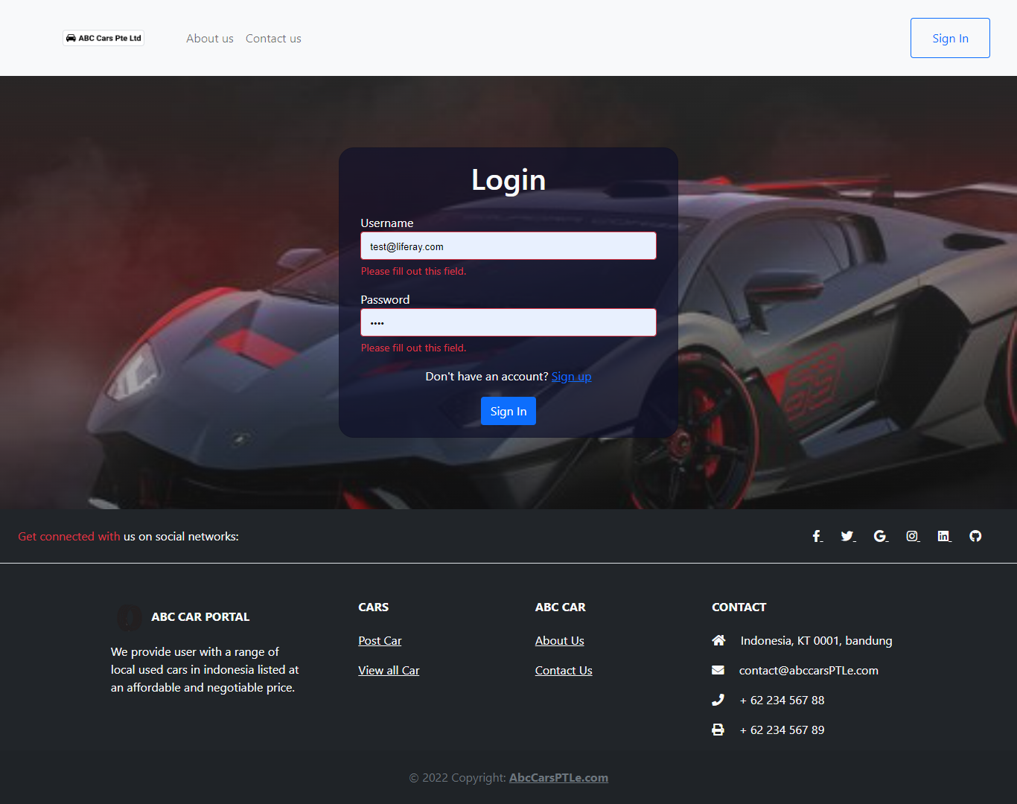

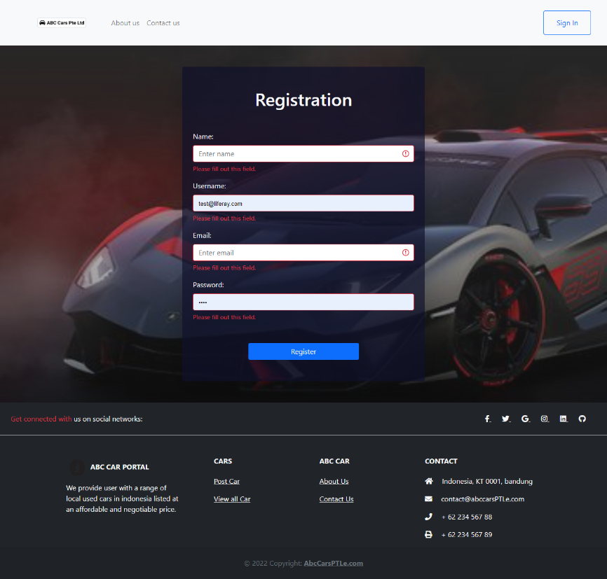**Registration.jsp**

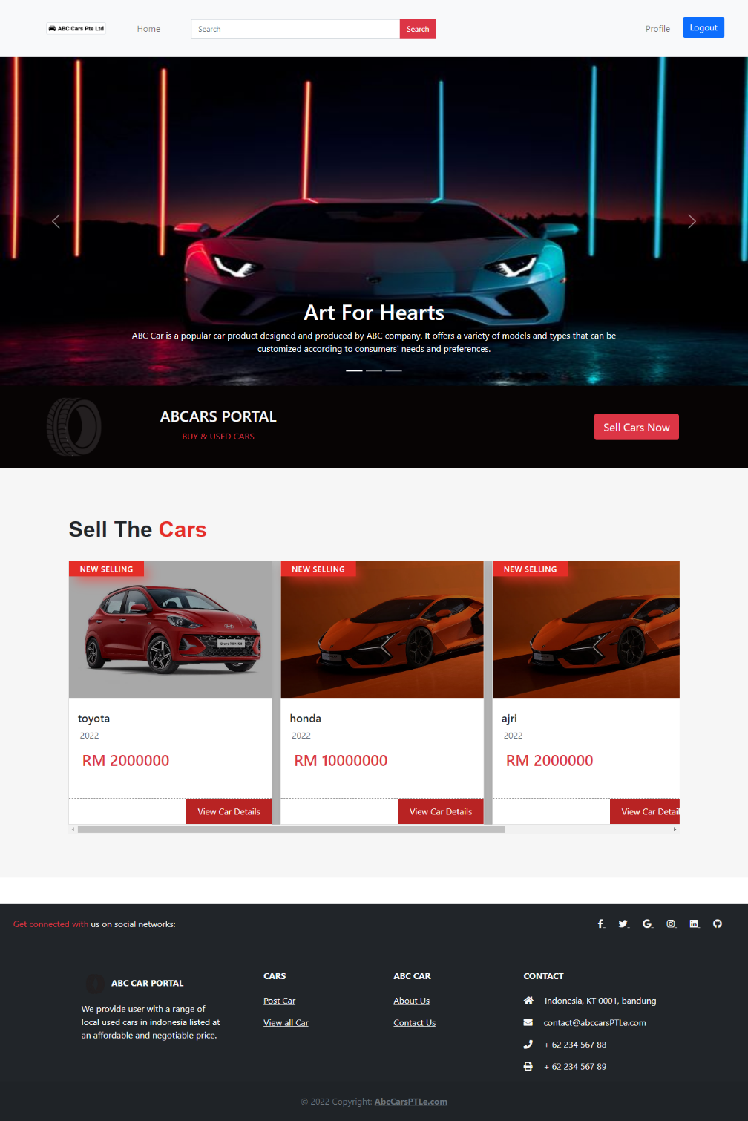**ViewsCars.jsp(Home page)**

**CarDetail.jsp**

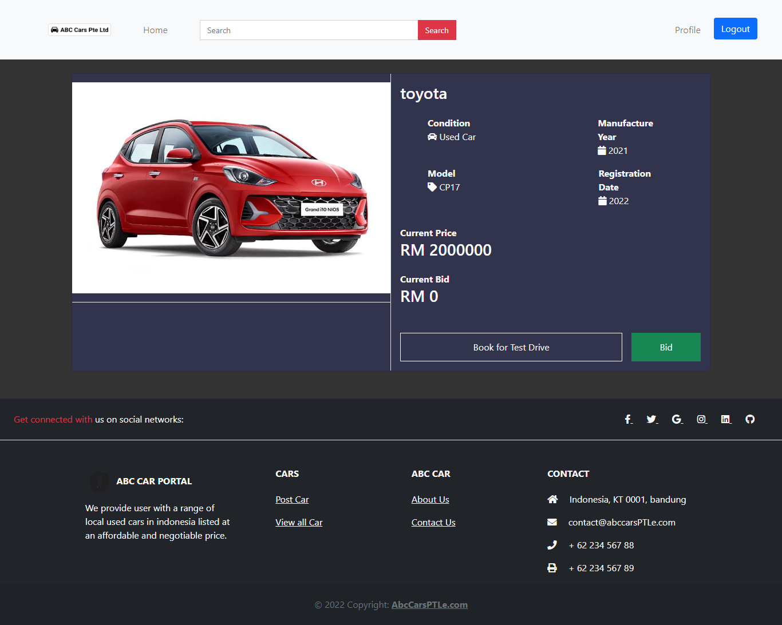

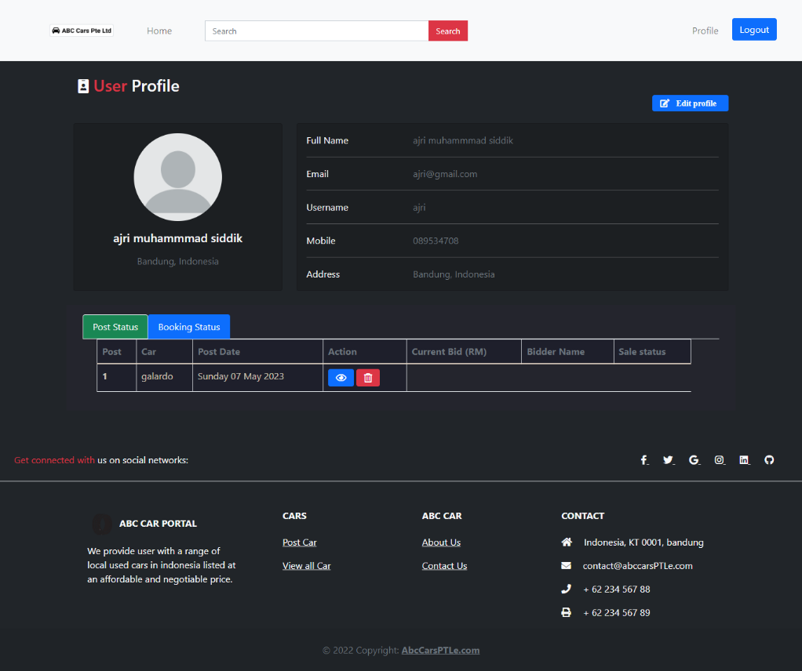**Profile.jsp**

**Admin page**

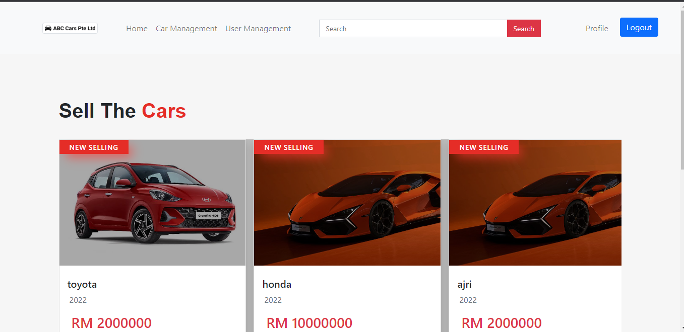

**AllCar**

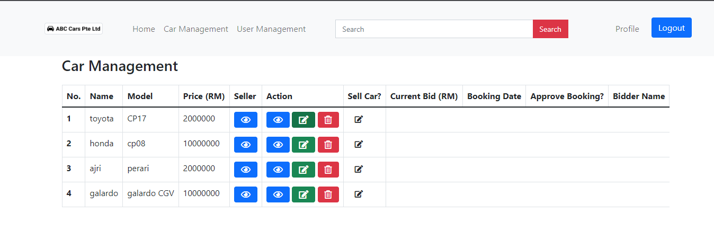

**AllUser**

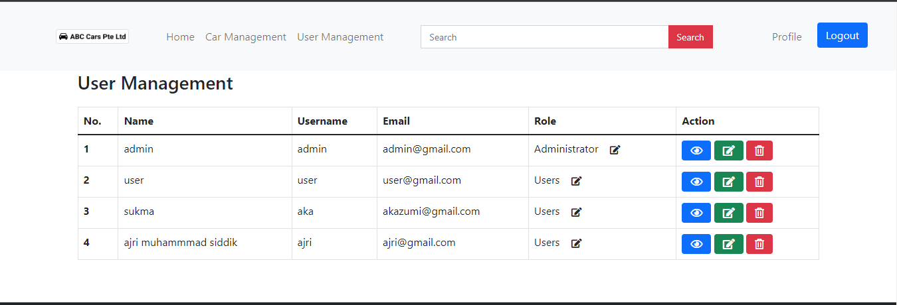

**Contact us**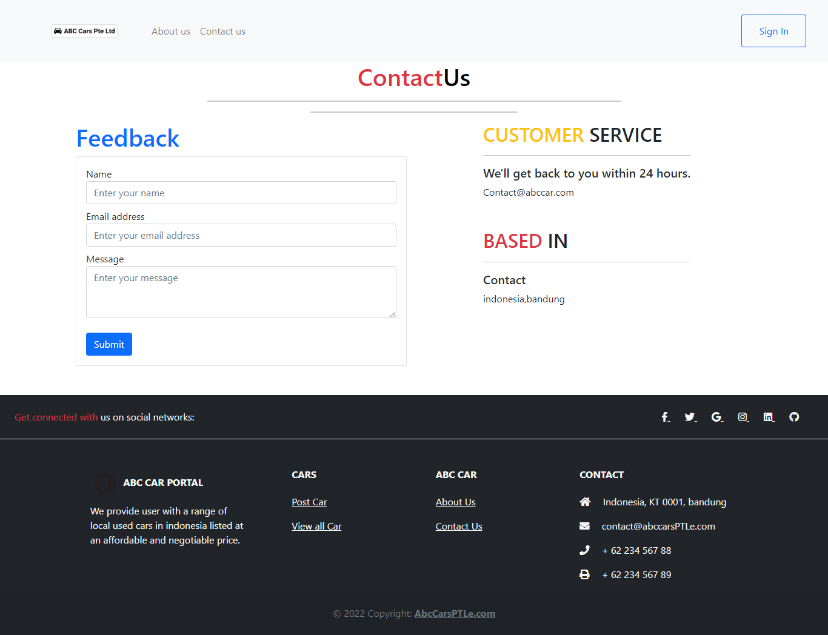

**about us**

